Little Rainbows Childcare Ltd
Buffery
Combined Policies, Procedures and Forms
September 2026

Contents
1. (COSHH) Policy Control of substances hazardous to health | 23. Non/late collection of child policy
2. Accident, Injury and First Aid Policy | 24. Nursery Chopping Board Colour Chart
3. Admission Policy | 25. Nursery Kitchen Temperature Chart
4. Arrival and Departure Policy | 26. Nutrition Policy
5. attendence management policy | 27. Retainer / Deposit Record
6. Behaviour Policy & Procedures | 28. Safeguarding/child protection policy
7. Biting in children under 2 Policy | 29. Safer sleeping practices - 2026
8. Bullying Policy & Procedures | 30. SEND Policy
9. CCTV Policy | 31. Suncream and Sun Safety Policy
10. Complaints Procedures | 32. Incident record form
11. Complaints Record | 33. Existing injuries record form
12. Confidentiality Policy | 34. Teething policy
13. E-Safety Policy | 35. Toilet Training Policy
14. Emergency Procedures | 36. Visitor Procedures
15. Food Hygiene and Safe Food Handling Policy | 37. Wearable Imagery Devices/Technology
16. Health and Safety Policy | 38. Working with Others Policy
17. Healthy Eating Policy | 39. Working with Parents Policy
18. Illness & Infection Control Procedures | 40. Medication Administration Procedure - Information for Parents
19. Low Risk Policy | 41. Emergency Medication Administration - Information for Parents
20. Medication Administration Policy | 42. Existing Injuries - Information for Parents
21. Missing/lost child policy | 43. Park Trip Risk Assessment Record
22. Mobile Phone and Personal Camera Policy | 44. Animals & Pets Policy  45. Lockdown Policy  46. Fire Evacuation Policy
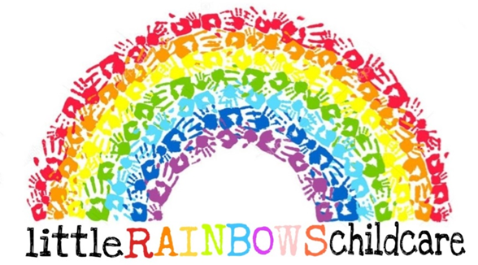

(COSHH) Policy Control of substances hazardous to health

Written by: Jasmine Dean Date: 09/03/26

1. Introduction
This policy outlines how the setting manages and controls substances that may be hazardous to health in accordance with the Control of Substances Hazardous to Health (COSHH) Regulations. The purpose of this policy is to ensure the health, safety and wellbeing of children, staff, visitors and contractors within the childcare environment.

2. Aim of the Policy
The aim of this policy is to ensure that all hazardous substances used within the setting are stored, handled, used and disposed of safely. This helps to reduce risks to children and staff while maintaining a clean and hygienic environment.

3. Scope
This policy applies to all staff members, students, volunteers and contractors who may come into contact with substances that could pose a risk to health within the setting.

4. Examples of Hazardous Substances
- Cleaning products such as bleach, disinfectant and sprays
- Anti-bacterial products and sanitising chemicals
- Dishwasher and laundry detergents
- Paints, glues and art materials
- Bodily fluids such as blood or vomit
- Medication administered to children
- Pest control substances

5. Responsibilities
Management responsibilities include:
- Ensuring COSHH regulations are followed within the setting
- Completing COSHH risk assessments for hazardous substances
- Providing appropriate training for staff
- Ensuring safety data sheets are available for chemicals used
- Ensuring substances are stored safely and securely away from children
Staff responsibilities include:
- Following COSHH procedures and training
- Using cleaning products safely and according to instructions
- Reporting hazards, spillages or unsafe practices
- Ensuring substances are returned to secure storage after use

6. Safe Storage
All hazardous substances must be stored in locked cupboards or secure storage areas that are inaccessible to children. Products must remain in their original containers with clear labels and safety instructions.

7. COSHH Risk Assessments
COSHH risk assessments are completed for all substances used within the setting. These assessments identify potential risks and outline the control measures required to ensure substances can be used safely.

8. Spillages and Accidents
In the event of a chemical spillage or accident involving hazardous substances, staff must follow the appropriate procedures, ensure children are kept away from the area, and report the incident to management.

9. Personal Protective Equipment (PPE)
Where necessary, staff must use appropriate PPE such as gloves or aprons when handling cleaning chemicals or bodily fluids. PPE will be provided by the setting. For example: when changing a child’s nappy, they must use an apron and gloves.

10. Staff Training
All staff will receive guidance on COSHH procedures as part of their induction and ongoing health and safety training. This ensures staff understand how to safely use and manage hazardous substances.

11. Monitoring and Review
The manager is responsible for reviewing this policy annually or sooner if legislation changes. COSHH assessments and safety procedures will also be monitored to ensure compliance.

Policy Approval

Signed: J.Dean and C.Chubb Review Date: 09/03/29
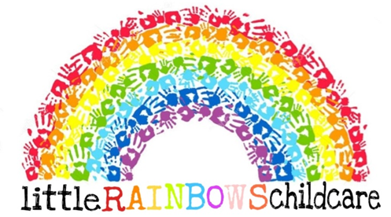
Accident, Injury and First Aid Policy
Written by: Emily Garbett Date: 10.03.2026

we aim to keep children safe. we stay within the ratios required by the Early Years Foundation Stage – see my Admission Policy for more information about ratios.

we ensure my premises and equipment are safe to use through constant, robust risk assessments – see my Health and Safety Policy for more information.

If a child has an accident
Children do sometimes have accidents. we have completed a Paediatric First Aid training course and we will use my knowledge to help them. We have a fully stocked first aid box appropriate for use with early years children in the house and another first aid kit which we take on outings.

we will record information about the accident and any first aid administration on an Accident and First Aid Record form and ask parents to sign – ideally on the same day. If we do not see parents, we will message them to let them know that their child has had an accident and the steps we took to support their child.

Serious accidents and injuries
If we are unable to help the child or if we are concerned about an injury we will –
- Contact emergency services to request an ambulance – 999 from the house phone and 112 from a mobile phone
- Follow advice from emergency services
- Inform parents as soon as possible to come and collect their child or meet them at hospital depending on what is decided
- If necessary send the child with emergency services in an ambulance.
Please note that we will normally be unable to travel with the injured child due to having other children in my care.

After a serious accident, in addition to parents, I am required to notify –
- Ofsted - enquiries@ofsted.gov.uk
- The Health and Safety Executive - http://www.hse.gov.uk/riddor/
- My insurance company.

We will make all records including my Risk Assessments and my Accident and First Aid Record available to other agencies or professionals on request.
Risk assessment – risk assessments do not need to be in writing to comply with the Early Years Foundation Stage or Childcare Register. Risk assessments demonstrate how we aim to keep children safe. I regularly look back at accident forms and do a further risk assessment after an accident or injury to ensure I am taking all necessary steps to protect children. We will then make changes to the environment, resources, equipment etc if we feel it is appropriate to keep children safer. Please see my Health and Safety Policy for more information.

Accidents at home – it is important that parents tell me about any accidents or injuries their child has had at home so I can make a record of what happened and contact emergency services or take advice from the child’s doctor if they are ill during the day. When parents inform me about accidents or injuries that have happened at home, we will complete an Accident at Home Record form and ask parents to sign.

Record keeping and retention – we am required to retain Accident, Injury and First Aid Record forms relating to serious or life-changing accidents until the child is 21 year and 3 months old for insurance purposes; we are required to retain documentation relating to minor accidents for ‘a reasonable period of time’ which is generally accepted to be 3 years. we will keep documentation as safely and confidentially as possible during this time.

If you have any questions about my Policy / Procedures or would like to make any comments, please ask.

Signed: Review date: 10.03.2029
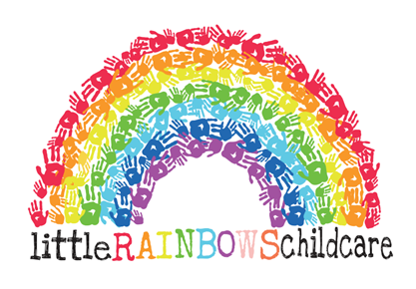
Admission Policy

Written by: Chloe Chubb Emily Garbett Date: 09/02/2026

We are inclusive childcare provider and we are happy to welcome all children and their families to our setting. We currently provide care for children from local schools / pre-schools and children of pre-school age.

Ratios - EYFS requirement 3.41 – Babies 1-3, toddlers, 1-5, preschool 1-8..

We comply with the requirements of the Early Years Foundation Stage and stay within statutory ratios at all times.

Reserving a space – if parents wish to reserve a space you need to speak to us about your requirements and our availability. If we can help you, we will provide you with a Childcare / Parent Contract, Fees Policy and copies of my Safeguarding and Child Protection and Complaints Procedures.

Please complete the Childcare / Parent Contract and related paperwork and return it to us with the deposit or retainer agreed during our discussions to secure your child’s place.

If you have any questions about our Policy / Procedures or would like to make any comments, please ask.

Signed: C.Chubb E.Garbett Review date: 09/02/2029
Arrival and Departure Policy
Written by: Emily Garbett Chloe Chubb Date: 09/02/2026

To reflect the Government’s social distancing rules, the following Arrival and Departure Procedures will be implemented for all children and parents with immediate effect:

Arrival Procedures
- Please ring the doorbell on arrival, we will be checking the ‘intercom’ camera to see who it is.
- Stand back from the door so we can see you.
- Maintain 6ft from other parents, waiting in a socially distanced queue when necessary.
- We will open the door and invite your child to come inside.
- Your child will be asked to wash their hands – with support if necessary. All children will be supervised during hand washing and taught our routine which we will share with you, so you can use it at home.
- Your child’s arrival time will be recorded on the daily register.

**Medication administration – you will find Medication Forms available by the door. If your child needs medication, please fill one in, sign and date it for us. Please note that we cannot give your child medication without a completed and signed form.
**If your child is ill, keep them at home – please do not ask us to make doorstep decisions
**Keeping in touch: if you have any information to share with us, you are welcome to text us or use WhatsApp or email. You will need to inform us about, for example, anything related to your child’s learning, development, current interests or progress and accidents, injuries or incidents at home.

Departure Procedures
- Please ring the doorbell on arrival. We will be checking the ‘intercom’ camera to checking who it is.
- Stand back from the door so we can see you.
- Maintain 6ft distance from other parents, waiting in a socially distanced queue when necessary.
- You will then be able to enter the building, and go to the allocated room where you should knock and wait.
- We will have a very quick chat with you if time and circumstances allow.
- Your child’s departure time will be recorded on the daily register.

In an emergency
If you fall ill during the day, you might need to send someone we haven’t met before to collect your child. If we do not know the person please contact me to inform me who is coming to collect the child and then we will ask them for a password, agreed with you in advance; if they cannot provide the password, they will not be allowed to collect your child from us – this is a safeguarding requirement.

**If you need to speak to us, we will be available on the phone between 7 a.m. and 7 p.m.

Signed: C.Chubb E.Garbett Review date:09/02/2029
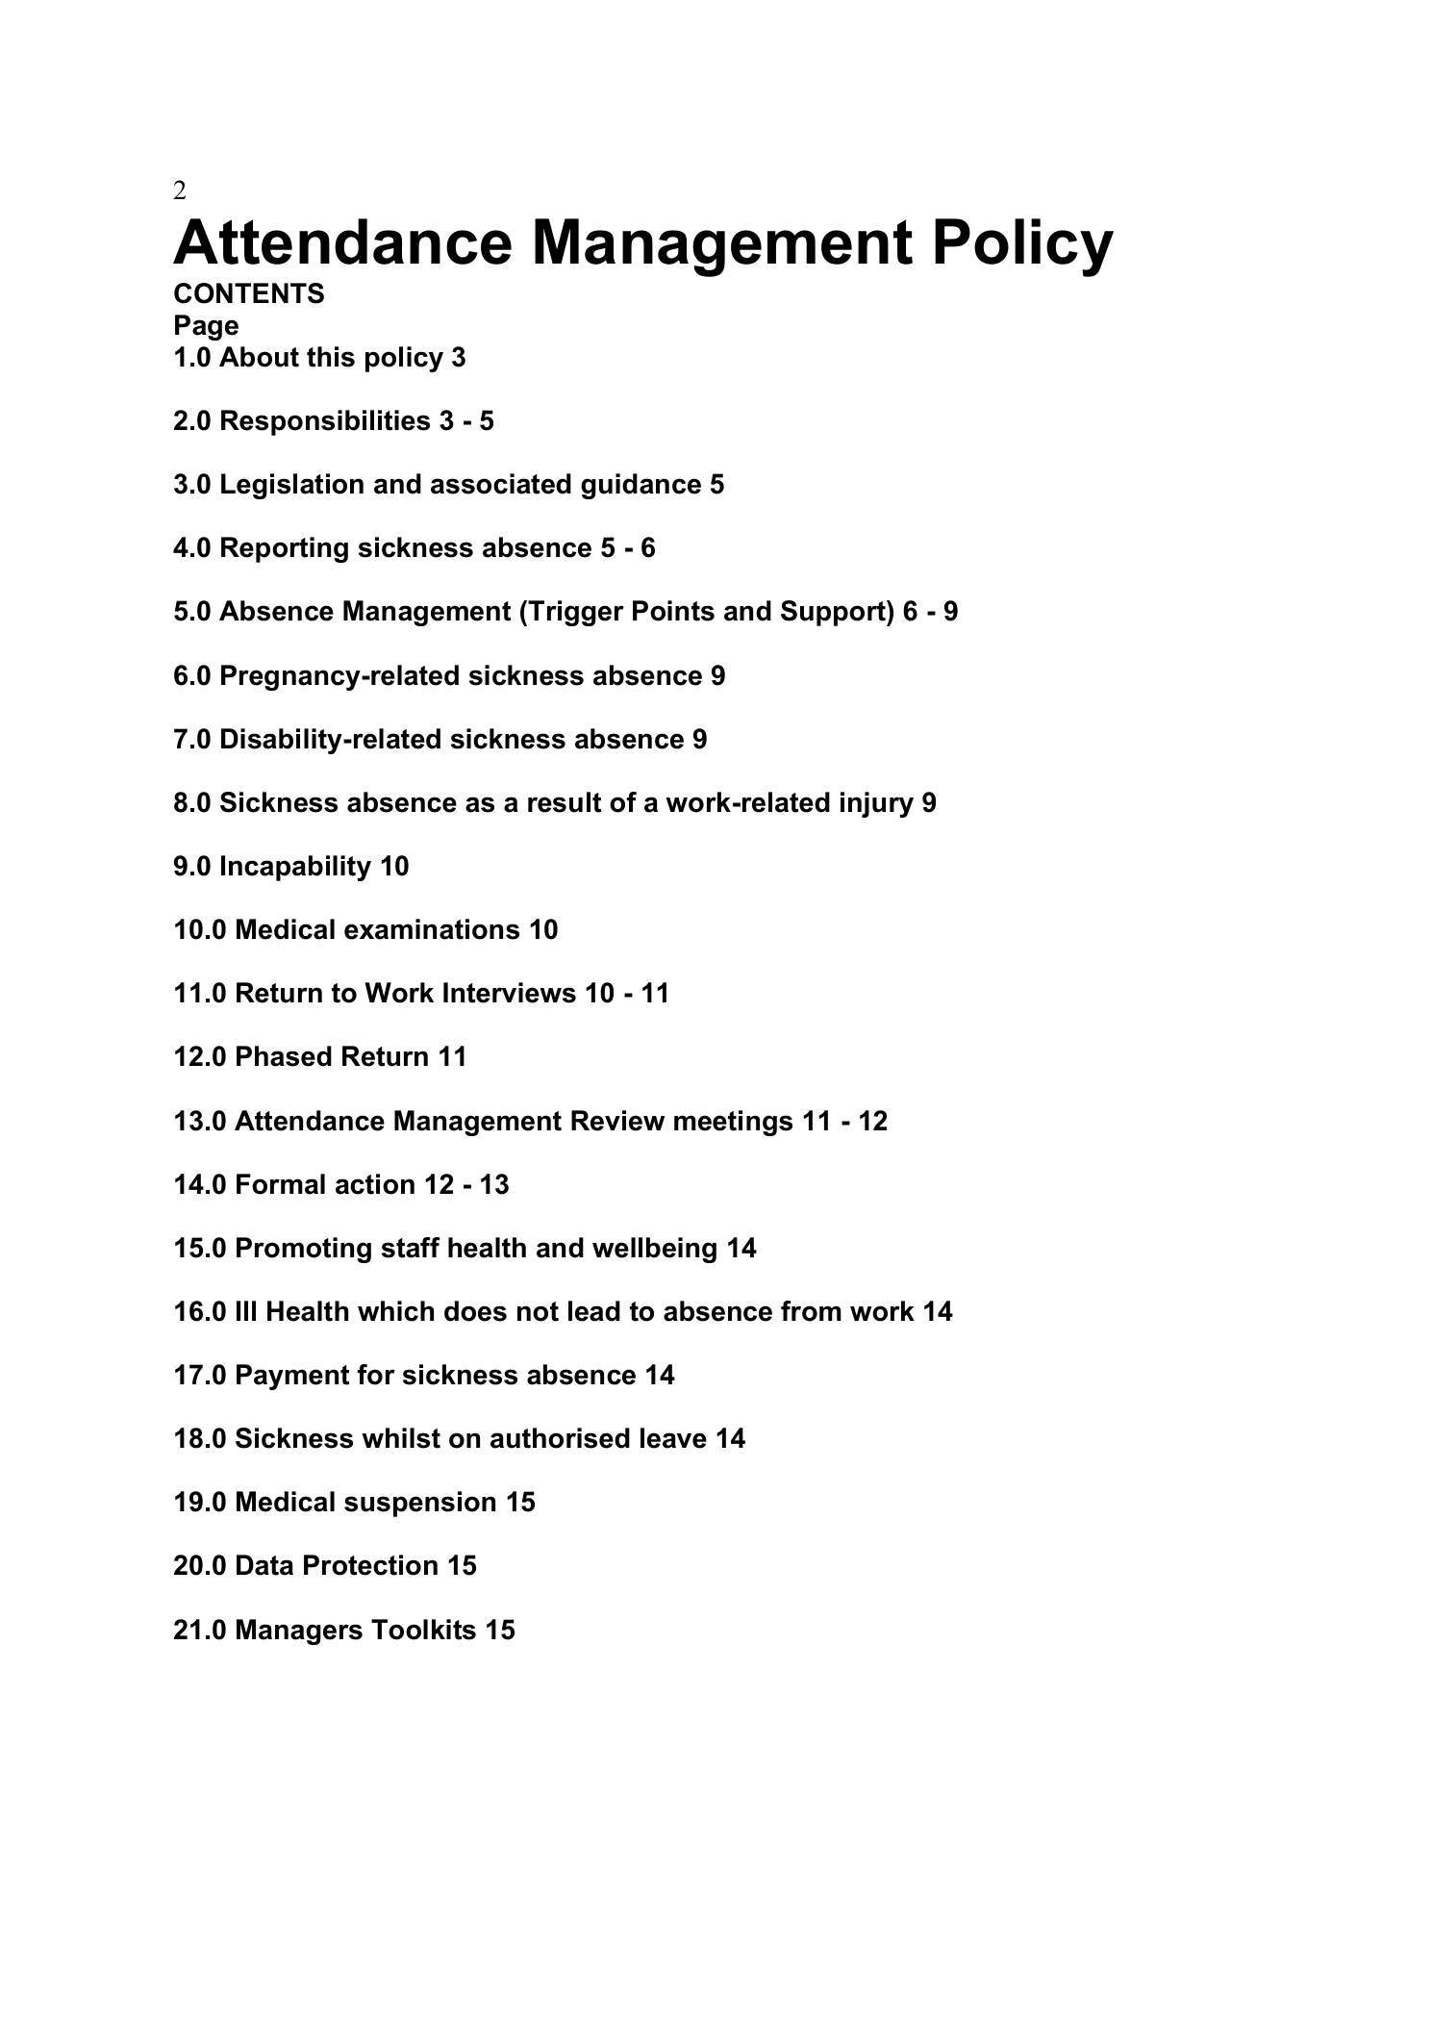
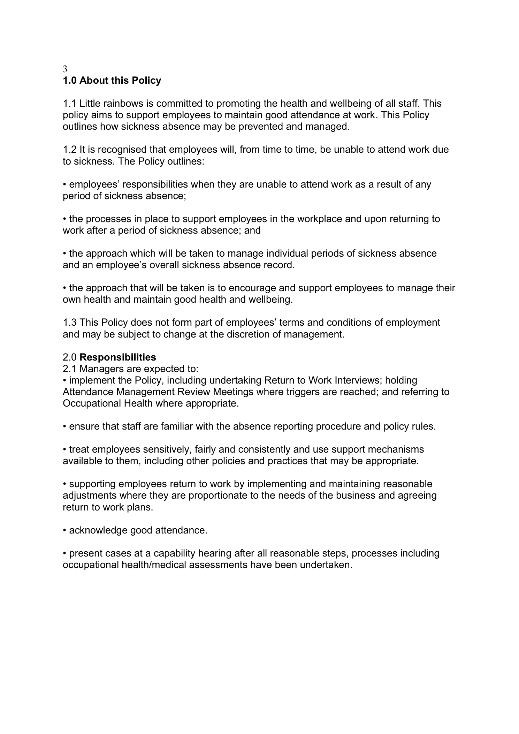
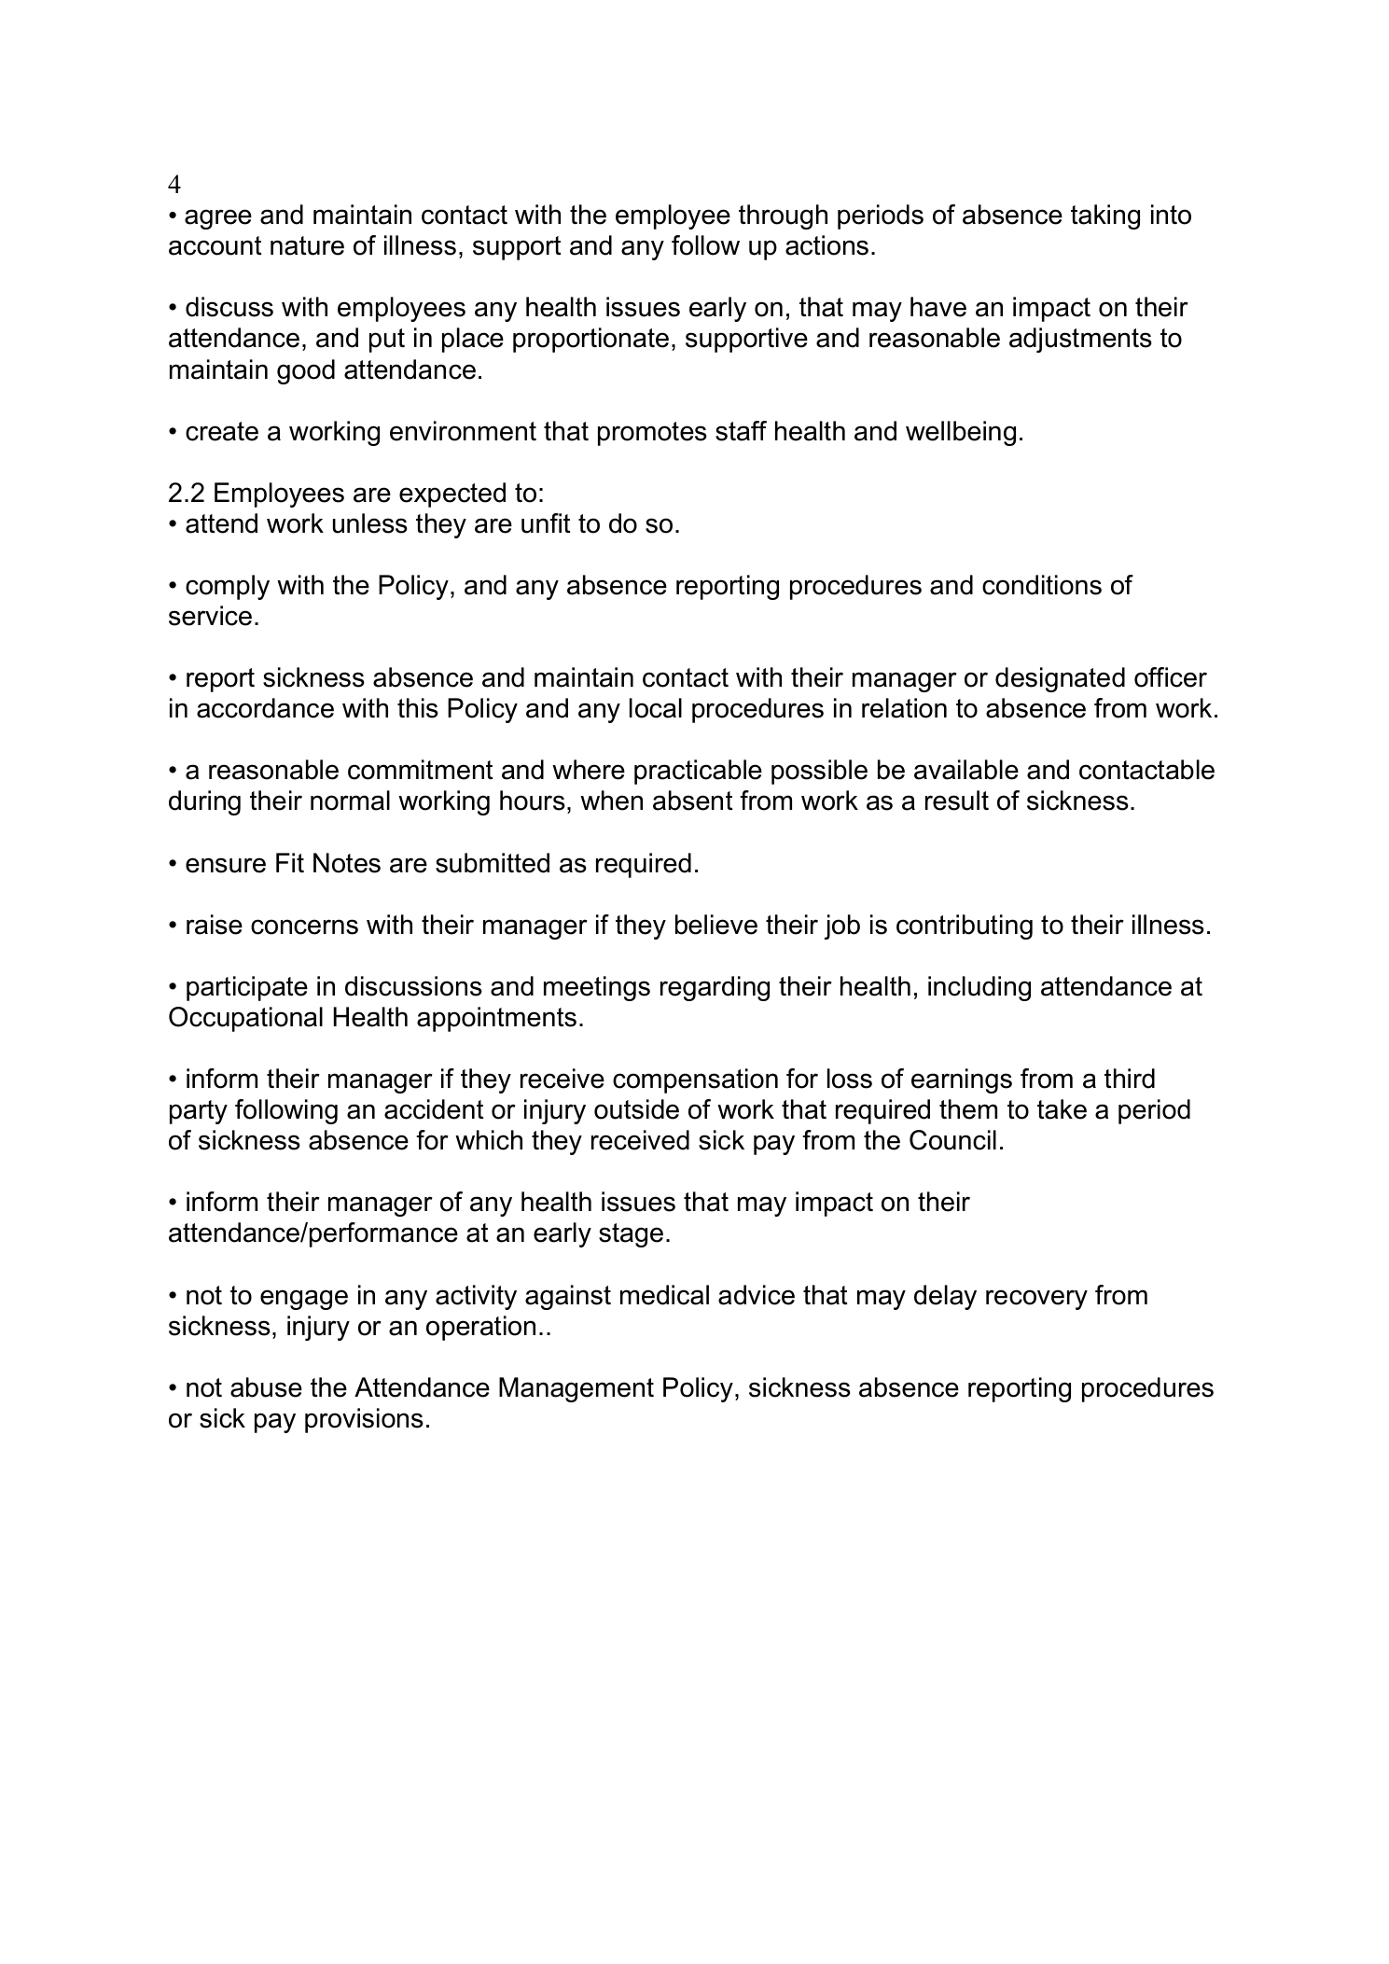
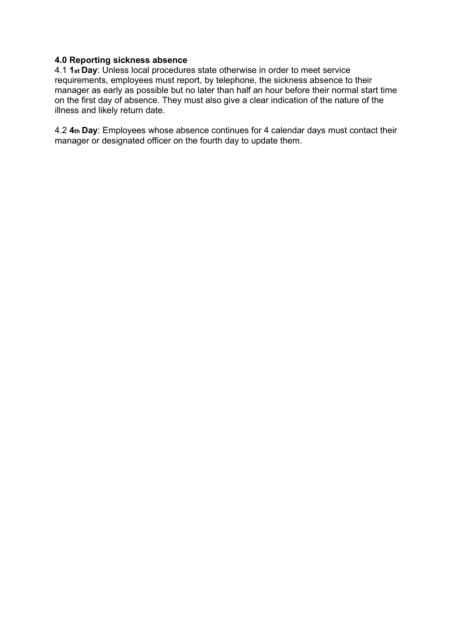
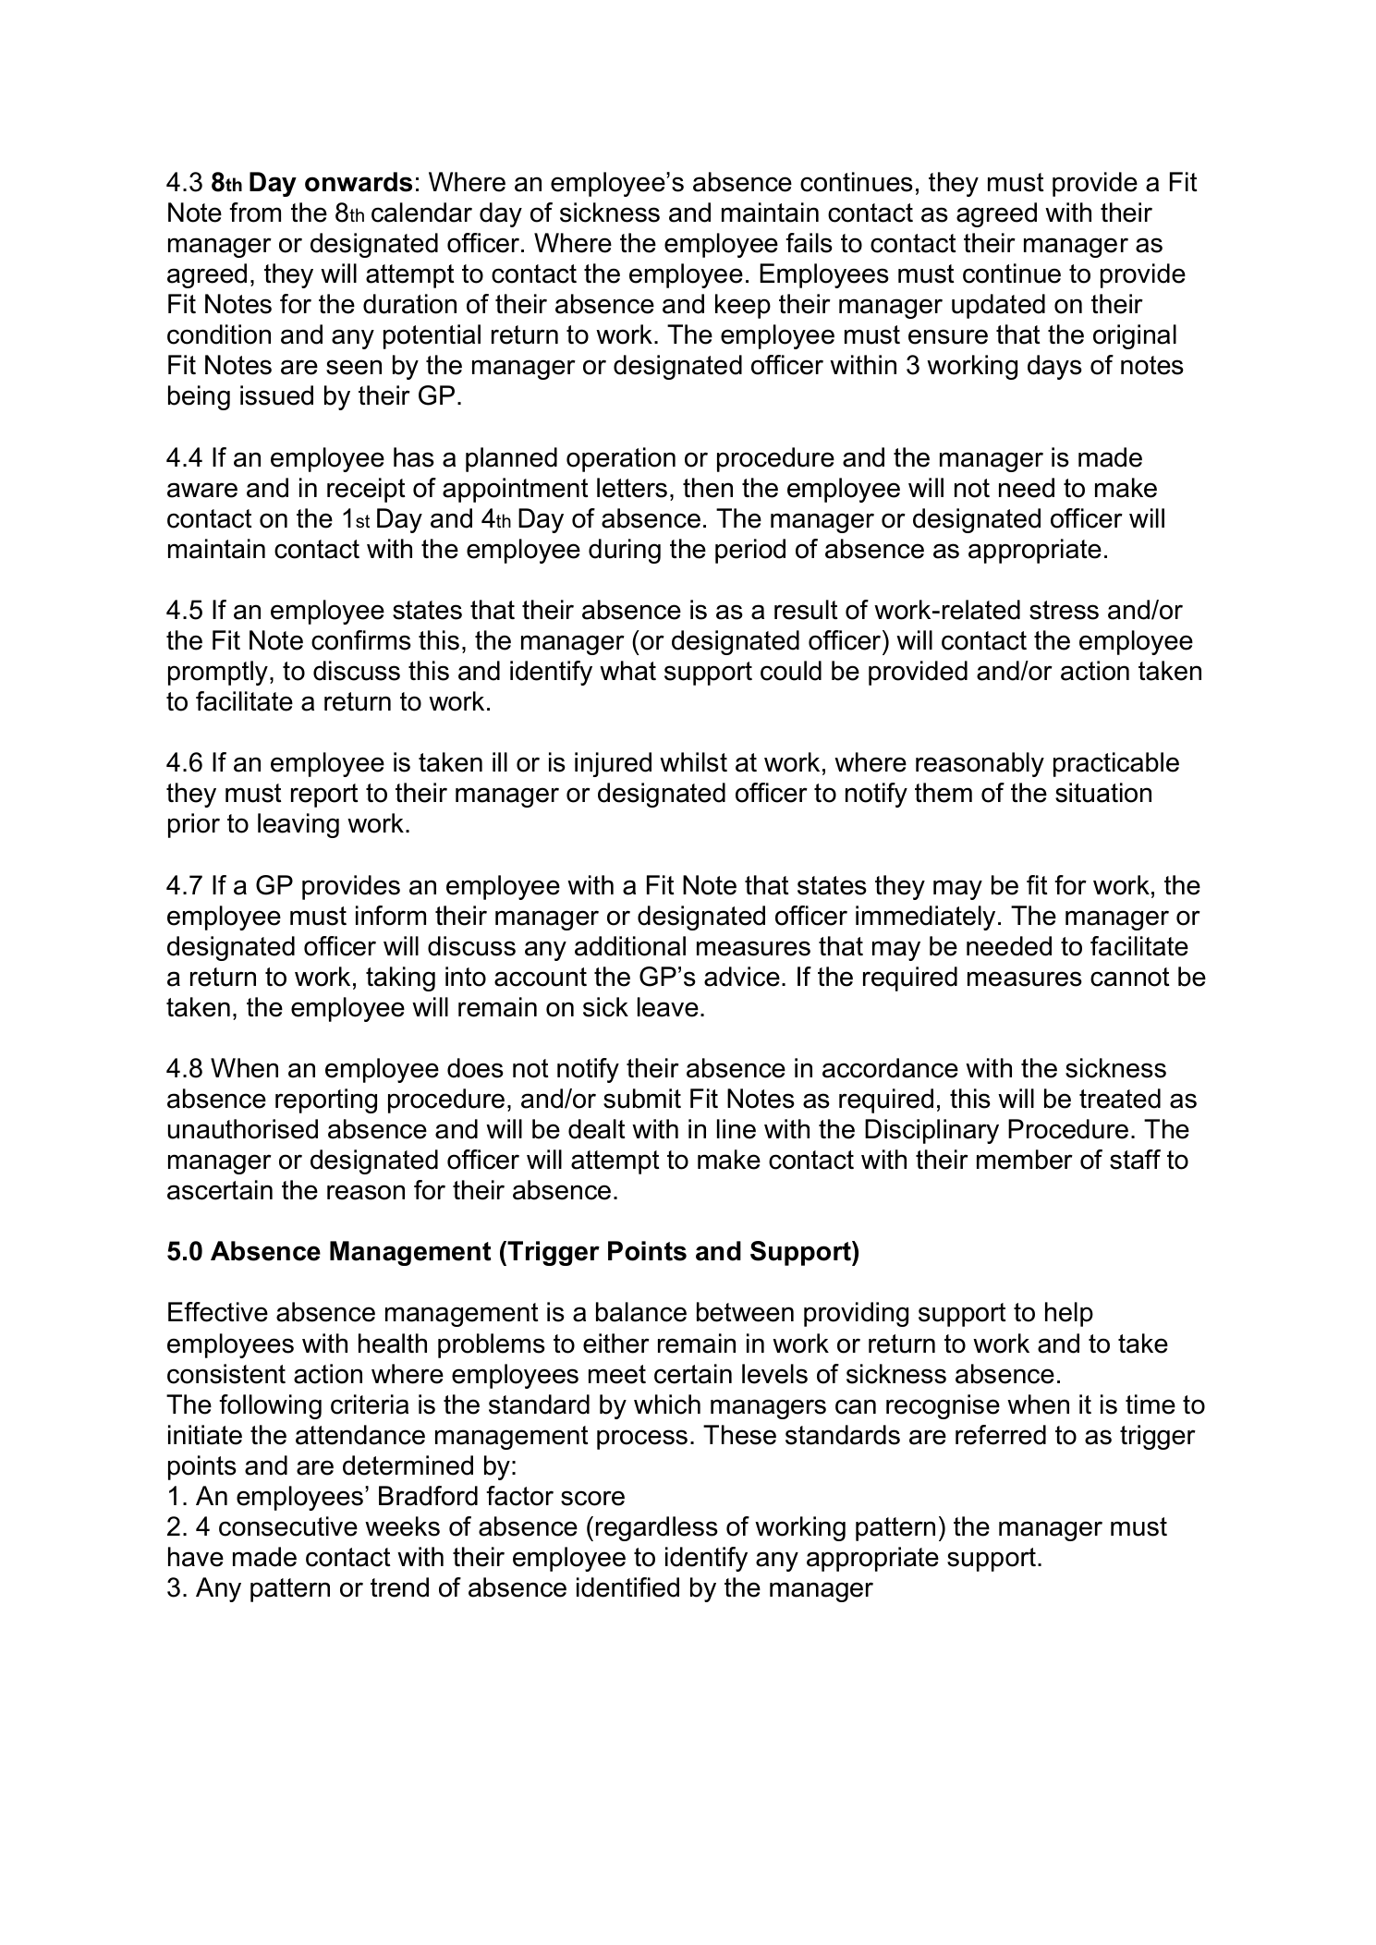
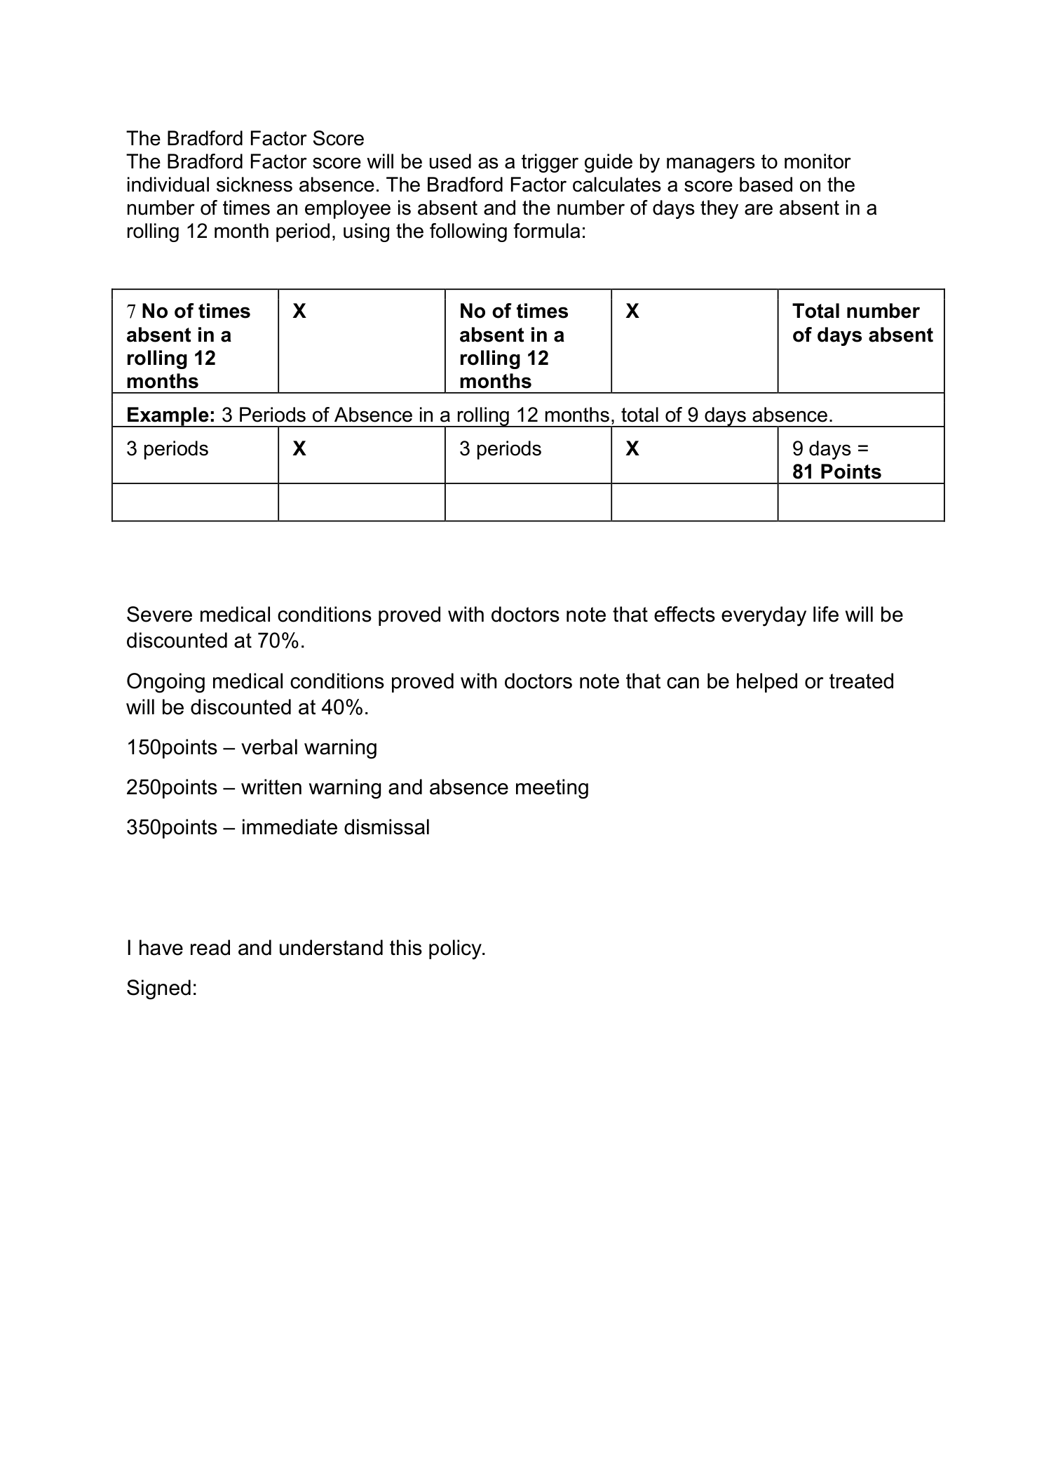
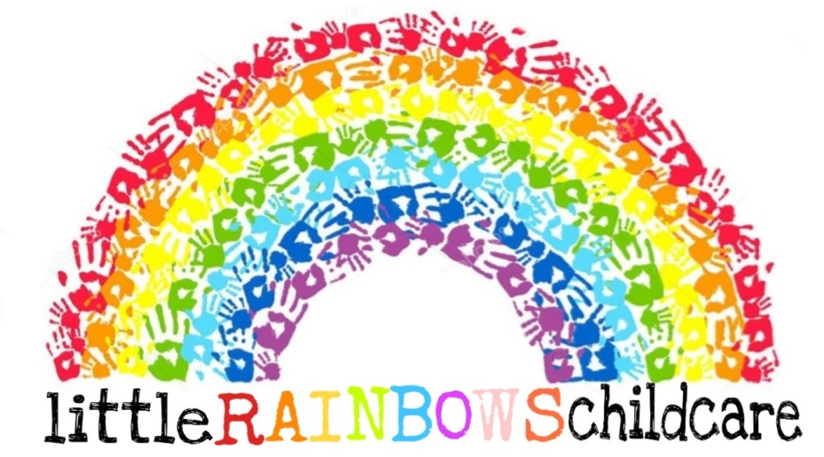
Behaviour Policy & Procedures

Written by: Chloe Chubb & Jasmine Dean Date: 05/02/2025

we aim to support all children’s behaviour consistently, working closely with parents to ensure children are supported to enjoy and achieve in their learning journey and reach their full potential.

Managing behaviour - EYFS requirement 3.52 - Providers are responsible for managing children’s behaviour in an appropriate way.

Behaviour includes everything a child says and does that can impact or influence someone else. We believe that children need clear, developmentally appropriate expectations to support their behaviour and we encourage children to develop acceptable behaviour by providing a happy, safe environment. We set a good example and aim to be a positive role model and ask older children to do the same. We work closely with the children and their parents to encourage good behaviour and my behaviour goals have been written with input from the children.

Behaviour procedures - We aim to support behaviour in ways appropriate to the age and stage of the child as follows –
- Distraction – We gently remove the child from the situation and offer alternative games.
- Discussion – We talk to the child, in a developmentally appropriate way, about their behaviour. We make sure the child knows it is the behaviour we do not like, not them. We do not tell a child they are ‘naughty’ as this can become a self-fulfilling prophesy.
- Returning to play - children are invited to return to play when they are ready to join in and they are asked to think again if they continue to behave inappropriately.

Working with parents – there is an expectation that parents work together with me to support their child and, if there is a concern which needs addressing, to improve any unwanted or what Ofsted refer to as ‘poor’ behaviour quickly. Records will be maintained as required by the Early Years Inspection handbook.

Teaching children – We spend time explaining to a child why they have been removed from play or why their behaviour has not been appropriate. We talk about the behaviour, how it impacts others and how it might be changed to stop this from happening again. As part of my continued personal, social and emotional development (PSED) interventions, I work closely with all the children and teach them how to play together cooperatively and offer them ideas for solutions / suggest positive ways to approach others.

Behaviour escalation strategy - if a child’s behaviour causes ongoing concern We will –
- Talk to the child in the first instance, allowing time for calm and contemplation;
- Aim to attend behaviour training to make sure we are supporting the child in the best possible ways;
- Complete an Incident Record to record the ‘poor behaviour’ as required by the Early Years Inspection handbook for the child’s parent to sign to keep them updated;
- Invite parents to a meeting (preferably without the child) to discuss the ongoing situation and decide a combined strategy. We reserve the right, with permission from parents as appropriate, to ask advice from other professionals, ensuring confidentiality where possible – see Permission Form for more information;
- Speak to other settings the child attends (if appropriate) to liaise about behaviour strategies. This will help ensure we can support the child through consistent behaviour management in all settings;
- Monitor the child’s behaviour alongside parents and other settings / agencies.
The meeting will be recorded and parents will be asked to sign.

Note - if a child’s behaviour does not improve and it is affecting their learning or the learning of other children in the setting, We will call a further meeting with parents to consider next steps to better meet their child’s needs. We ask parents to recognise the importance of resolving behaviour concerns so their child can return to playful learning as quickly as possible.

Corporal punishment - EYFS requirement 3.51 - Providers must not give corporal punishment to a child. Providers must take all reasonable steps to ensure that corporal punishment is not given by any person who cares for or is in regular contact with a child, or by any person living or working in the premises where care is provided. Any early years provider who fails to meet these requirements commits an offence.

We are aware that corporal punishment and the threat of using corporal punishment is illegal and will not be used in the provision. I will never administer physical punishment or any form of punishment with the intention of causing pain or discomfort, humiliation or hurt. I am aware of the requirement to ‘whistleblow’ if I believe a child has been harmed by corporal punishment (see Safeguarding and Child Protection Policy and Procedures) for more information.

Record keeping – it is a requirement of the Ofsted Early Years Inspection handbook that records of ‘poor’ behaviour are shared with Ofsted during inspection. These records will be shared with parents. Records must be retained for ‘a reasonable period of time’ to comply with the EYFS and will then be destroyed.

If you have any questions about my Policy / Procedures or would like to make any comments, please ask.

Signed: C.Chubb J.Dean Review date: 05/02/2028
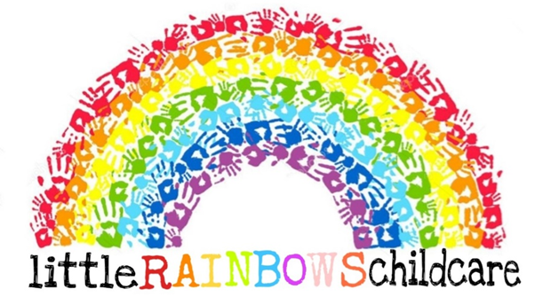

Biting in children under 2 Policy

Written by – Little Rainbows childcare ltd Date: 05/02/2026

Biting is a common and normal part of development in a child and occurs often in the early years of childhood most commonly between the ages of 12-30 months. Biting often stems from a child’s sensory desire and instinct to place things into the mouth. Biting may not always indicate pain or discomfort and is sometimes witnessed during periods of excitement , under or overstimulation and may be used when a child is struggling to communicate or display feelings in an appropriate way. Biting may also be used in children when teething as a way to ease the feeling and to add texture and stimulation to the gums. During teething it is also common for children to suckle or rub their gums or teeth on familiar objects ie hands ,clothes comforters ect(see teething policy)
As most bites occur during episodes of teething or discomfort parents/carers of children who suspect that their child is teething will be asked to inform practitioners at the door or via a phone call or text message. If practitioners suspect teething this will also be feedback to the parent/carer of the child.
Following an incident of biting the behaviour policy will be followed
- The child who has bitten will be moved to another area of the room away from the child they have bitten to provide distraction
- The bite will be spoken about in an age appropriate manner. In under 2’s this may include small simple words and teething distractions will be given (teething toys , frozen rings rattles ect.)
- Triggers will also be noted and the cause of the event documented.
In the event that a second bite occurs the parent/carer of the child will then be informed. If the bites appear of a serious nature ie bruising to the skin appearing to have punctured/broken the skin or leave a large teeth mark the child will be placed on a final warning and the parent/carer will be asked to collect the child if a third occurs. This is to ensure all children and others are safeguarded.
Following the occurrence of 2 or more serious bites. These will be identified by the breaking of the skin, bruising or large teeth marks. Over a 3 week recurrent time period (on the days the child is in the setting ) the parent/carer of the child will be called in for a provision meeting to discuss the most suitable method to assist the behaviour and to prevent it happening. Triggers or signs will also be discussed in this meeting.

Signed: C.Chubb J.Dean K.Thornley Review Date: 05/02/2029
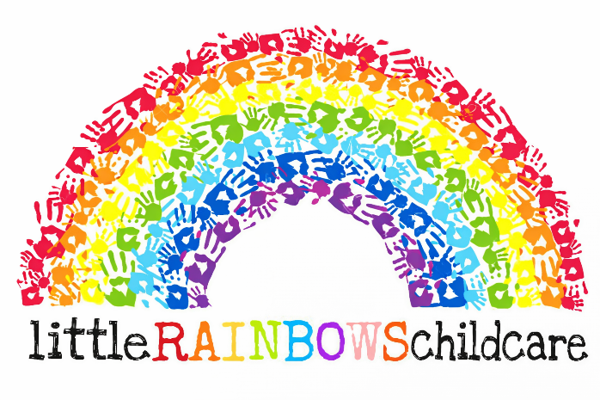

Bullying Policy & Procedures
Written by: Jasmine Dean and Chloe Chubb Date: 05/02/2026

Bullying can take many forms: from a child pushing and biting another child to ‘peer-on-peer’ abuse - see ‘Keeping Children Safe in Education’ statutory guidance which Ofsted inspectors must ‘have regard to’ during inspection and which the EYFS states that childcare providers will find useful.

If a child is bullying another child in the provision, we will supervise them closely and call a meeting to speak to their parents, following our behaviour procedures and behaviour escalation strategy (as detailed in our Behaviour Policy and Procedures). We will aim to support the child using targeted teaching interventions.

If a child is being bullied in the provision or elsewhere we will speak to parents and aim to support them to work through their emotions and deal with bullying situations as they arise.

Record keeping – We will keep records of any instances of bullying or what the Ofsted Early Years Inspection handbook refers to as ‘poor behaviour’. A parental signature will be requested on the same day (if possible). We will share these with parents and might be required to share them with other professionals or agencies on request.

We reserve the right to request support from other professionals or agencies to help care for the child who is bullying or being bullied by others as this is something we’re not qualified to do on our own.

Record keeping - records relating to behaviour must be retained for ‘a reasonable period of time’ to comply with EYFS requirements.

If you have any questions about our Policy / Procedures or would like to make any comments, please ask.

Signed: Review date:
CCTV Policy

Written by: Chloe Chubb and Jasmine Dean Date: 08/06/2026

Within our nursery all areas that children have access to will be on camera with visual and audio.
Location of the CCTV within Little Rainbows Childcare LTD Tipton,

- Garden
- Outside front door
- Downstairs Hallway
- Office
- Downstairs Corridor
- Staff room
- Lil lion’s main room
- Lil Lion’s sleep room
- Stairs
- Upstairs landing
- Giraffes main room
- Giraffes Sensory room
- Giraffes messy room
- Little monkey’s main room
- Little monkeys’ messy room
- Outside back of the building where bins are stored.

All CCTV footage is kept within our storage system located in the office, to which the manager and owner have access too. Following the GDPR policy and guidelines CCTV is stored for 14-31 days, then discarded appropriately. All parent/guardians sign permission forms for us to allow cameras to be always recorded to which the footage is only used in emergencies and to re-call actual time framed events in line with safeguarding and protecting the children.

To be reviewed on ……. 08/06/2029

Signed
C.Chubb
J.Dean
Complaints Procedures

Written by: Chloe Chubb Jasmine Dean Date: 05/02/2026

This is a statutory procedure.

EYFS requirement 3.74 – Providers must put in place a written procedure for dealing with concerns and complaints from parents and/or carers, and must keep a written record of any complaints, and their outcome.

If parents wish to make a complaint about any aspect of our care of their child related to the Early Years Foundation Stage (EYFS) or Childcare Registers* they can do so verbally; alternatively, parents might prefer to complete a Complaints Form (attached) which will be provided on request.

EYFS requirement 3.74 – All providers must investigate written complaints relating to their fulfilment of the EYFS requirements and notify complainants of the outcome of the investigation within 28 days of having received the complaint.

All complaints will be treated confidentially and, to comply with the requirements of the EYFS will be investigated within 28 days of receipt.

Ofsted will be notified of any complaints relating to the requirements of the EYFS or the Childcare Register and any complaints relating to safeguarding might also be reported to the Local Safeguarding Children Board (LSCB). Depending on the nature of the complaint, it will be investigated internally or passed to Ofsted and / or the LSCB to investigate.

The outcome of any complaint investigation will be discussed with the complainant if contact details are provided. If the complainant is still unhappy, or at any time in the complaints process, they can contact Ofsted (details to follow).

EYFS requirement 3.74 – The record of complaints must be made available to Ofsted or the relevant childminder agency on request.

A record of complaints will be retained for 3 years and made available to Ofsted on request.

EYFS requirement 3.75 - Providers must make available to parents and/or carers details about how to contact Ofsted if they believe the provider is not meeting the EYFS requirements.

If parents wish to contact Ofsted direct the contact details are –
- Telephone - 0300 123 1231;
- Address - Ofsted, Piccadilly Gate, Store St, Manchester M1 2WD;
- Email - enquiries@ofsted.gov.uk. The Ofsted parents / complaints poster is displayed.

*Note – information about my registration on the Childcare Register is provided to parents as required by the Childcare Register.

Contacting the Information Commissioners Office
If your complaint is regarding a data breach, related to the General Data Protection Regulation (GDPR) I must report the breach within 72 hours and you have the right to complain: if a data breach could result in discrimination, reputation damage, financial loss or loss of confidentiality occurs.
Parents can contact the Information Commissioners Office (ICO) for further information
– https://ico.org.uk/for-organisations/report-a-breach/.

Retention requirements
The EYFS requires me to keep a written record of the complaint to share with Ofsted; I might be required to share it with other agencies depending on the nature of the complaint.
The Childcare Register (relating to children over the age of 5 years) requires me to keep a written record of the complaint for 3 years, including details about the outcome of the investigation and any action taken.
To comply with GDPR, the Complaint Record and other documentation will be shredded (paper records) or securely deleted (online records) after the required retention period.

Signed: C.Chubb J.Dean Review date: 05/02/2029
Complaints Record
How to complete the complaints record –

- Date – this must be recorded because there is a limited time to deal with the complaint.
- Source of the complaint – record who made the complaint. Be aware of confidentiality as other parents may read the form. Use notes eg ‘child A’ or ‘adult B’ when recording information of this nature.
- Nature of the complaint – this relates to the EYFS. Record which requirement is appropriate and tick. If it is a complaint related to the Childcare Registers, note.
- Details of the complaint – make a brief note of the details of the complaint.
- How it was dealt with – tick the relevant method and write any additional details in the box. Record details such as if other parents were interviewed, whether any other staff members were involved in the investigation, whether outside agencies were asked for advice or approached for guidance etc and attach paperwork as appropriate.
- Actions – what must be done to resolve things? Maybe Ofsted have given actions that must be completed. In some cases other agencies require changes to be made to retain registration.
Also reflect on how the business in the future might benefit from what has happened. For example, policies may be re-written or parents and children might be involved in a different way from now onwards.
If other childminders were involved or someone was dismissed as a result of the complaint, then Ofsted must be informed – 0300 123 1231.
- Date complainant informed – inform the person who made the complaint in writing about the outcome and retain a copy of the letter.
- Date parents informed – parents must be advised that a complaint has been made and they must be given details about the outcome. Remember confidentiality for the complainant.
- Date procedure completed – note when the complaint is completed.
- Childminder’s details – sign and date the form and put it in the complaints folder.

If you have any questions about my Policy / Procedures or would like to make any comments, please ask.

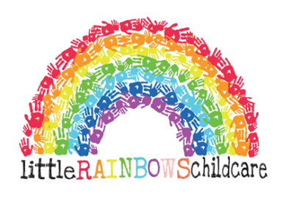
Complaints Record Form

Date of complaint –
² Source of complaint - tick as appropriate
Parent (in writing, including email)  Anonymous  Ofsted (attach letter) | Other -
³ Nature of complaint - tick as appropriate
EYFS - safeguarding  EYFS - learning and development  Childcare Register  Financial / contractual | Other –
⁴ Details of the complaint –

Continue on a separate paper if necessary
If allegation is of abuse or serious harm inform LSCB / Child Protection Agency & Ofsted
within 24 hours by phone and follow up in writing within 14 days.
⁵ How it was dealt with | Details –
Internal investigation
Investigation by Ofsted
Investigation by other agencies
⁶ Actions | Details –
Internal actions
Actions agreed with Ofsted
Changes to conditions of registration
Other action taken by Ofsted
No action
Actions imposed or agreed with other agencies
⁷ Date the person who raised the complaint notified of outcome – | ⁸ Date parents notified of outcome and given a copy of the complaint –
EYFS & Childcare Register – notification must be within 28 days
⁹ Date procedure completed – Attach all relevant documentation.
¹⁰ Childminder’s name – Signature – Date –
EYFS and Childcare Register - this document must be retained for 3 years for
inspection by Ofsted
Confidentiality Policy
Written by: Chloe Chubb Jasmine Dean Date: 05/02/2026

Parent and child confidentiality are respected, and we ask that parents and children respect all of the staff’s confidentiality.

Talking to parents - EYFS requirement 3.60 – Providers must ensure that there is an area where staff may talk to parents and/or carers confidentially.

Parents can speak to us confidentially (without children or other parents listening in) on request.

Privacy - EYFS requirement 3.69 – Providers must ensure that all staff understand the need to protect the privacy of the children in their care as well the legal requirements that exist to ensure that information relating to the child is handled in a way that ensures confidentiality.

All information relating to children and families is stored securely and treated confidentially, unless we have permission to share it or there is a child protection / safeguarding issue. You will be made aware of what information is stored about you and your child and deleted when there is no longer a need for it to be retained – see our Privacy Notice for more details.

GDPR compliance – the 6 Principles of the General Data Protection Regulation (GDPR, 2018) state that information must be treated with:
- Fairness, lawfulness and transparency;
- Purpose limitation;
- Data minimisation;
- Data quality;
- Security, integrity and confidentiality.

With relation to ‘confidentiality’ this means that personal data relating to children and their families: must be processed in a manner that ensures appropriate security, including protection against unauthorised or unlawful processing and against accidental loss, destruction or damage, using appropriate technical or organisational measures.

Paperwork storage - we store childminding information via paperwork, the computer, mobile phone (parent numbers) and camera/children’s tablet (photos of children); we take photos of children to help me meet the requirements of the EYFS.

we take confidentiality very seriously - both staff confidentiality and that of the children and families who use our setting. We are aware that parents might need to share confidential information with us about their child or their family situation and we will not use this information for any reason other than to consider how we might best support the child.

We aim to promote confidentiality by –
- Sharing our confidentiality policy with parents and reminding parents about the importance of not sharing personal or family information online;
- Being registered with the Information Commissioners Office as a data handler;
- Keeping information safe on the computer and mobile phone – see Mobile Phone and Camera Policy;
- Making parents aware that their details will only be passed to other agencies with their written permission; or shared confidentially with other agencies if there is a safeguarding issue;
- Advising parents that in some situations we are required to work with other settings or agencies such as nurseries, pre-schools and the Children’s Centre to support their child’s learning and / or development – this is a requirement of the Early Years Foundation Stage (EYFS) – see Consent and Discussion Form for more information;
- Advising parents that, at times, it is impossible for me to maintain absolute confidentiality – for example, if a child has an infectious disease, we have a duty to inform other parents;
- Advising parents of any relevant organisations that have requested a disclosure of personal information and records unless expressly requested not to do so by the said agency in writing; or if we have been asked for information in connection with court proceedings.

If you have any questions about my Policy / Procedures or would like to make any comments, please ask.

Signed: C.Chubb J.Dean Review date: 05/02/2029
E-Safety Policy
Written by: Chloe Chubb Jasmine Dean Date: 05/02/2026

The use of technology is growing, and children are exposed to technology from a very young age. We recognise the benefit of using electronic devices to support children’s learning in our provision and to help us comply with the record keeping and learning and development aspects of the Early Years Foundation Stage.

E-safety covers all electronic devices including cameras, computers, videos and DVD recorders, mobile phones and other devices capable of taking photographs or linking to the internet. It also includes the use of social media, software, emails, chat rooms, blogs, laptops, games consoles and new technology as we are aware that internet and technology is constantly evolving.

For more information about how we use mobile phones and cameras, please see our Safeguarding and Child Protection Policy and Procedures.

How the internet is used
The internet is used in different ways in the setting:
- The Early Years Foundation Stage requires providers to teach children about technology which is generally accepted to include learning about the internet. we aim to take a common sense approach to how long children spend using ICT during the day and the suitability of ICT resources for various ages of children. Parents are consulted about time spent on the internet and, for example, watching television and their wishes are followed. Parents, please do not allow your child to bring electronic games rated over the age of the child.
- Staff use the internet to input learning and development information about children; share learning and development information with children’s parents; store personal data bout children and their families
- Management use the internet to complete payroll; send messages including email to parents and children; share information with families and staff.
The risks of using the internet
We are aware of the risks of allowing staff and children to go online on computers, tablets, mobile phones, watches, gaming etc and:
- we aim to supervise use to protect children and staff when using the internet;
- we share safe internet messages with parents so they can support their children’s internet use and keep them safer at home;
- we teach children about how to use the internet safely and monitor their use;
- we train staff to keep online information secure and to raise awareness of the risks of radicalisation and extremism on the internet and online bullying;
- Staff including volunteers and students are only given access to children’s online data when training has been provided and a Data Sharing Agreement signed;
- Staff and children are made aware of the risks of being online and know how to report any concerns.

Keeping data safe
we understand that while technology is useful for learning it can also present safety problems when misused and this policy has been written to clarify appropriate technology use within the provision and by parents of children who attend my provision when related to childminding and childminded children and –
- The broadband is secured by a password;
- Virus protection software is automatically updated;
- Online learning journey systems are secured with a password which is changed regularly;
- Passwords are used for all online systems;
- Laptops, tablets and other ICT equipment which contain sensitive data about children, families and staff are secure and do not leave the premises;
- Tablets and laptops ‘time out’ to a password protected page when unused;
- The password to any secure documents is shared with my partner to ensure it remains secure should I be injured or fall ill.

Online communications
All internet enabled devices are monitored to ensure safe internet use. Any technology used by children has internet safety controls in place so children cannot access inappropriate sites. Every effort will be made to keep internet security updated and online usage by children will be monitored. Any uploading of personal information onto websites must be carried out in compliance with the Data Protection Act 1998 and will not be done without prior written permission from the parent involved.
- The website, Facebook group - blog … does / does not contain photos of children and staff.
Note – if photos of children or staff are used online consent (parent or staff member permission) must be sought in writing in advance and can be withdrawn at any time.
- When emails are sent to parents, BCC is used to protect private email addresses;
- Use of work related ICT equipment will be monitored and work-related equipment must not be used for private or social networking purposes;
- We are trained to recognise the importance of ensuring all communications between myself, parents and children are professional and respectful. If concerning comments are made by myself or parents etc on social media, I will not respond;
- We are trained to understand that information about children and families will not be shared online, including on social media.

We are registered with the Information Commissioner’s Office - ICO - www.ico.gov.uk: please see ourICO registration certificate.

If there is a concern about e-safety, we will act on the concern to comply with the requirements of the EYFS, Childcare Registers, Ofsted and the ICO.

If you have any questions about my Policy / Procedures or would like to make any comments, please ask.

Signed: C.Chubb J.Dean Review date: 05/02/2029
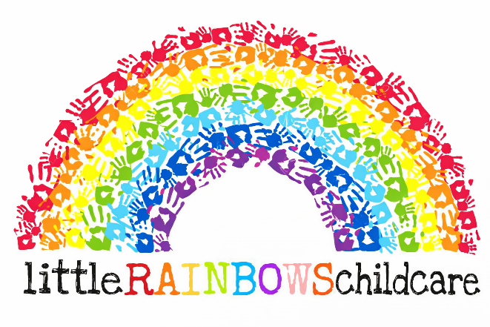

Emergency Procedures
Written by: Jasmine Dean and Chloe Chubb Date: 05/02/2026

We’re committed to keeping children safe and ensuring they know what to do in an emergency.

EYFS requirement 3.55 - Providers must take reasonable steps to ensure the safety of children, staff and others on the premises in the case of fire or any other emergency, and must have an emergency evacuation procedure. Providers must have appropriate fire detection (for example, fire alarms and smoke detectors) which is in working order. Fire exits must be free of obstruction and easily opened from the inside.

At Little Rainbow’s Childcare Ltd we carry out regular fire practices with the children - see Emergency and Fire Record. All emergency exits are risk assessed, kept clear from clutter and are safe for all children including disabled children / adults to exit in an emergency. Keys to outside doors are kept in safe places and are accessible to adults.

To protect the children we have a carbon monoxide detector and smoke detectors on all floors.

Emergency procedures
- To exit safely with all people on the premises and wait in a safe place.
- To ring 999 and request the attendance of the Fire Brigade and ambulance service if required.
- To follow advice from Emergency Services in the event of being caught up in a terrorist or other attack.
- To make every effort to contact parents or children’s emergency contacts (see Emergency Contact Information form) and ask them to collect their child as quickly as possible.
Note: parents are asked to keep emergency contact information updated regularly.
- To write an Incident Report and ask parents to sign to state they are aware of what happened and the action that was taken to protect their child/ren.
- To inform Ofsted and my Insurance Company that a serious incident has occurred and follow their advice.

If you have any questions about Little Rainbows Policy / Procedures or would like to make any comments, please ask.

Signed: Review date:

Food Hygiene and Safe Food Handling Policy
This policy outlines the procedures for safe food hygiene and handling within the nursery setting. The aim of this policy is to ensure that all food prepared, stored and served within the setting is safe for children, staff and visitors. The policy follows guidance from the Food Standards Agency, the Early Years Foundation Stage (EYFS) framework and relevant food safety legislation.
The nursery is committed to maintaining high standards of food hygiene to prevent food contamination and foodborne illness. This policy ensures that all staff understand their responsibilities when handling, preparing or serving food.
Responsibilities
Management responsibilities include:
- Ensuring the setting complies with food hygiene regulations
- Ensuring staff receive appropriate food hygiene training
- Maintaining a clean and hygienic kitchen environment
- Monitoring food preparation and storage procedures
- Ensuring food safety documentation is maintained
Staff responsibilities include:
- Following safe food handling procedures
- Washing hands before preparing or serving food
- Reporting any food safety concerns
- Ensuring food is stored safely and labelled correctly
- Maintaining cleanliness in food preparation areas

Hygiene
Staff involved in food preparation must maintain high levels of personal hygiene. This includes washing hands thoroughly before handling food, after using the toilet, after handling raw foods and after cleaning tasks. Staff should wear appropriate protective clothing such as aprons and tie back long hair.

Food Storage
All food must be stored safely to prevent contamination. Refrigerated food must be kept at appropriate temperatures and dry foods stored in sealed containers. Food must be clearly labelled with use-by dates and rotated using a first-in, first-out system.

Food Preparation
Food preparation areas must be kept clean and sanitised. Separate utensils and preparation areas must be used for raw and cooked foods to prevent cross-contamination. Staff must follow correct cooking temperatures to ensure food is safe to consume.

Allergies and Dietary Requirements
The nursery recognises that some children may have allergies, intolerances or specific dietary requirements. Information about children's dietary needs must be recorded and communicated to all relevant staff. Staff must ensure that food provided meets the child's dietary requirements and prevents exposure to allergens.

Cleaning and Sanitising
Kitchen surfaces, utensils and equipment must be cleaned and sanitised regularly. Cleaning schedules must be followed to ensure that food preparation areas remain hygienic.

Temperature Control
Refrigerators must be monitored regularly to ensure food is stored at the correct temperature. Hot foods must be served at safe temperatures and leftovers disposed of safely if not consumed.

Food Safety Training
All staff involved in food handling should hold an appropriate food hygiene qualification or receive training on safe food handling procedures.

Monitoring and Review
This policy will be reviewed annually or sooner if legislation or guidance changes. The nursery manager is responsible for ensuring compliance with food hygiene standards.

Policy Approval

Signed: J.Dean and C.Chubb Review Date: 09/03/29

Health and Safety Policy

Written by: Chloe Chubb Emily Garbett Date: 09/02/2026

We aim to ensure children are healthy and safe on my premises, in the garden and on outings.

This Health and Safety Policy follow’s the requirements of the Early Years Foundation Stage and covers –

- EYFS overarching statement
- Fire safety
- Hygiene requirements
- Hand washing
- Paediatric first aid
- First aid box / kit
- Risk assessment
- Outings
- Outside play
- No smoking
- Health and hygiene
- Other considerations including –
- Supervision of children
- Food and allergies
- Manual Handling
- Electrical appliances
- Chemicals
- Staff training

Responsibility
The owner / manager is responsible for health and safety in the setting; all staff must ensure the setting is as safe as reasonably practicable for use by the children and families.

Overarching statement in the EYFS

EYFS requirement 3.54 - Providers must ensure that their premises, including overall floor space and outdoor spaces, are fit for purpose and suitable for the age of children cared for and the activities provided on the premises.

we aim to ensure the premises and outside areas are fit for purpose by carrying out regular risk assessments of all areas of provision including furniture, equipment and toys. we clean the building and garden regularly and check for debris or dangers throughout the day.

Fire safety
EYFS requirement 3.54 - Providers must comply with requirements of health and safety legislation (including fire safety requirements).

We comply with fire safety requirements and have a written Fire Evacuation Procedure and a written Fire Risk Assessment.

Hygiene requirements
EYFS requirement 3.54 - Providers must comply with requirements of health and safety legislation (including hygiene requirements).

We keep the building and garden clean and hygienic for the children and staff.

Hand washing procedures - the government advice is to wash hands regularly for 20 seconds, using soap and water or sanitiser if no soap is available. Hands should be dried well, using single use paper or cloth towels (hot washed after each use). With prior written parent permission, a dab of hand cream can then be rubbed in gently to stop hands cracking. My Ongoing Medication Administration Form has been updated to reflect the changes.

Paediatric first aid
EYFS requirement 3.25 - At least one person who has a current paediatric first aid certificate must be on the premises and available at all times when children are present, and must accompany children on outings.

We are committed to keeping children safe - however, accidents do sometimes happen. we have up-to-date paediatric first aid certificates and the children are within sight and / or hearing at all times. we risk assess constantly to help keep children safe and we teach them to do their own risk assessments (see below).

First aid box
EYFS requirement 3.50 - Providers must ensure there is a first aid box accessible at all times with appropriate content for use with children. Providers must keep a written record of accidents or injuries and first aid treatment. Providers must inform parents and/or carers of any accident or injury sustained by the child on the same day, or as soon as reasonably practicable, of any first aid treatment given.

There is a fully equipped first aid box in the house and one for outings and the car. The contents are suitable for children and are replaced after use or as required. we keep completed Accident and First Aid Record forms in each child’s personal file and ask parents to complete an Existing Injuries Record if their child has had an injury at home.

Parents are asked to make themselves available on the same day (where possible) to read and sign accident and first aid records. we are aware of the requirement to notify Ofsted of any serious accident, illness or injury, or death to Ofsted within 14 days.

Risk assessment
EYFS requirement 3.64 - Providers must ensure that they take all reasonable steps to ensure staff and children in their care are not exposed to risks and must be able to demonstrate how they are managing risks. Risk assessments should identify aspects of the environment that need to be checked on a regular basis, when and by whom those aspects will be checked, and how the risk will be removed or minimised.

We take children’s safety seriously and risk assess first thing in the morning and constantly during the day, covering outside play, inside activities, outings etc. The house and garden are visually checked for risks and faulty equipment, furniture, broken or dangerous resources etc are removed from the play areas immediately. Children are taught to do their own risk assessments of the house and garden and are reminded about safety during outings.

We teach children about keeping themselves safe and taking measured risks. For example, we plan regular activities linked to teaching children about personal safety, stranger danger, staying safe online, being careful around animals and road and rail safety etc… we use planned activities and spontaneous opportunities to talk to the children about keeping safe.

we share information with parents to support their child’s health and safety at home.

Outings
EYFS requirement 3.65 - Children must be kept safe while on outings. Providers must assess the risks or hazards which may arise for the children, and must identify the steps to be taken to remove, minimise and manage those risks and hazards. The assessment must include consideration of adult to child ratios.
EYFS requirement 3.25 - At least one person who has a current paediatric first aid (PFA) certificate must be on the premises and available at all times when children are present, and must accompany children on outings.
EYFS requirement 3.66 - Vehicles in which children are being transported, and the driver of those vehicles, must be adequately insured.

Outings are risk assessed to ensure children are kept safe and we always work within my ratios. During outings, children might use large play equipment at parks or in soft play areas. These will be risk assessed first and children will be taught to inform an adult if they are worried about any aspect of the play areas.
we have a current paediatric first aid certificates and a first aid kit is taken on outings.

Outside play
EYFS requirement 3.58 - Providers must provide access to an outdoor play area or, if that is not possible, ensure that outdoor activities are planned and taken on a daily basis (unless circumstances make this inappropriate, for example unsafe weather conditions). Providers must follow their legal responsibilities under the Equality Act 2010 (for example, the provisions on reasonable adjustments).

The garden is as safe as possible and risk assessed before, during and after each working day. It is set up to support all children’s learning: resources and equipment are provided which promote children’s learning and development. Garden equipment, resources etc is risk assessed before, during and after use to ensure it is safe for the ages and developmental stages of the children in the setting on the day.

Parents are aware that it is a requirement of the Early Years Foundation Stage (EYFS) that their child goes outside every day apart from if there are unsafe weather conditions and are asked to provide appropriate clothing and spare clothes in case their child gets wet or muddy. We have spare clothes for children if required.

Garden equipment, resources etc is risk assessed before, during and after use to ensure it is safe for the ages and developmental stages of the children in the provision on the day.

Unsafe weather conditions might include storm warnings from the Environment Agency and very hot days when it is unsafe for children to stay in the sun for long periods. we use a weather app to check weather conditions every day and speak to parents about how we have supported their child’s learning if we have not been able to offer them the opportunity to go outside.

Sun safety – we ask parents to provide a bottle of labelled factor 50+ sun cream for their child. Permission is in place to apply cream and children are taught how to do this independently (with supervision). Parents are asked to put the first layer of sun cream on their child in the morning and we will continue to apply it regularly through the day.

No smoking
EYFS requirement 3.56 - Providers must not allow smoking in or on the premises when children are present or about to be present.

we do not smoke and we are committed to protecting children from the dangers of smoke and smoky atmospheres. Smoking and equipment in any form including e-cigarettes is not allowed on the premises. Where possible we protect children from smoking on outings. For example, we do not take the children into smoky environments and avoid places that allow smoking if possible.

We teach children about the dangers of tobacco and smoking in age appropriate ways, working with parents where possible to ensure messages are consistent.

Health and hygiene
EYFS requirement 3.60 - Providers must ensure there are suitable hygienic changing facilities for changing any children who are in nappies and providers should ensure that an adequate supply of clean bedding, towels, spare clothes and any other necessary items is always available.

Nappy changing and toilet facilities can be inspected at any time: anti-bacterial cleaning products are used to keep them clean and children’s hands are washed at appropriate times. Children are taught how to clean their hands effectively and we supervise them.

We will wash hands before and after nappy changing. Children are placed on a plastic mat which is cleaned with antibacterial wipes before and after each use. Privacy is considered when children’s nappies are changed but we must also be able to supervise the other children in the setting effectively.
Clean linen is available through the day and parents are asked to provide spare clothes for their child/ren.

Soiled clothes and other items are bagged up for parents to take home. All linen and cloths used in the setting is washed at high temperatures using non-biological powder to reduce the risk of cross contamination and allergies.

Other health and safety considerations
- Supervision of children – to comply with the EYFS, children are within sight and / or hearing of a staff member at all times.
- Food and allergies – we comply with Safer Food Better Business for Childminders; we ensure allergens are handled appropriately; we record allergens and make the information available to parents on request to comply with EU allergy legislation.
- Manual handling – we have updated out knowledge to understand the dangers of manual handling and how to lift and bend appropriately.
- Chemicals – information is available online about chemicals used in the setting; staff are trained in using chemicals safely and personal protective equipment is supplied as required.
- Staff training – if relevant, staff are trained on health and safety procedures during induction; ongoing training is provided by the owner / manager.

If you have any questions about our Policy / Procedures or would like to make any comments, please ask.

Signed: C.Chubb E.Garbett Review date: 09/02/2029
Healthy Eating Policy

Written by: Chloe Chubb and Jasmine Dean Date: 05/02/2026

We take pride in our healthy food and drink provision.

We provide healthy nutritious hot meals for the children every lunch time, healthy snack and high tea. However parents are welcome to bring in healthy lunchbox.

EYFS requirement 3.45 – Where children are provided with meals, snacks and drinks, they must be healthy, balanced and nutritious.

We are committed to offering children healthy, nutritious food which meets their individual dietary requirements as advised by their parents. All food is freshly prepared, using best quality ingredients where possible and presented well. Portion sizes are realistic and children are never asked to clear plates as we are aware of the risks of over-eating.

Teaching children – we teach children about healthy eating and drinking as part of our daily routine. Children help to buy, prepare and cook food and enjoy helping in the kitchen. Risk assessments help to keep children safe in the kitchen and when they are cooking.

Special food - food is often used as part of a festival, birthday or celebration and we sometimes offer children food which might not be considered healthy such as cakes for a birthday party. If parents have a concern about this they should let me know.

EYFS requirement 3.45 – Fresh drinking water must be available and accessible at all times.

Fresh drinking water is provided in age appropriate cups on a tray which is accessible for all the children.

EYFS requirement 3.45 – Before a child is admitted to the setting the provider must also obtain information about any special dietary requirements, preferences and food allergies that the child has, and any special health requirement. Providers must record and act on information from parents and carers about a child's dietary needs.

As part of induction, we ask parents about their child’s dietary needs. we consider likes, dislikes, allergies, intolerances, religious and cultural needs

EYFS requirement 3.47 – Registered providers must notify Ofsted of any food poisoning affecting two or more children looked after on the premises. Notification must be made as soon as is reasonably practicable, but in any event within 14 days of the incident. A registered provider, who, without reasonable excuse, fails to comply with this requirement, commits an offence.

I am aware of the requirements under the Public Health (Infection Diseases) Regulations 1988 regarding food poisoning and the requirement to inform Ofsted, acting on advice given by the Health Protection Agency. If I have to make a report an Incident Record will be completed.

EYFS requirement 3.48 - There must be an area which is adequately equipped to provide healthy meals, snacks and drinks for children as necessary. There must be suitable facilities for the hygienic preparation of food for children, if necessary including suitable sterilisation equipment for babies’ food. Providers must be confident that those responsible for preparing and handling food are competent to do so. In group provision, all staff involved in preparing and handling food must receive training in food hygiene.

We are registered with the Local Authority Environmental Health Department as a food provider. We use the guidance ‘Safer Food Better Business for Childminders’ from the Food Standards Agency. We are aware of the requirement to report food poisoning affecting two or more children cared for on the premises. Baby equipment can be sterilised using hot or cold-water techniques.

If you have any questions about my Policy / Procedures or would like to make any comments, please ask.

Signed: C.Chubb J.Dean Review date: 05/02/2029
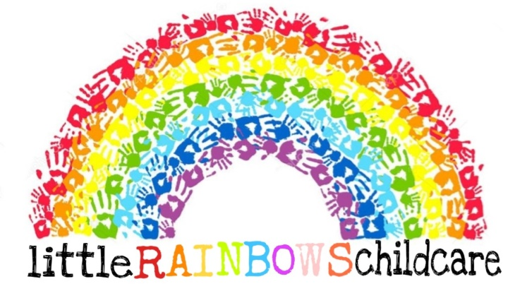
Illness & Infection Control Procedures
Written by – Chloe Chubb & Jasmine Dean | Date – 05/02/2026
All steps are taken to protect children from illness and infection.

EYFS requirement 3.44 states –
‘The provider must promote the good health of children attending the setting. They must have a procedure, discussed with parents and/or carers, for responding to children who are ill or infectious, take necessary steps to prevent the spread of infection, and take appropriate action if children are ill.’

Illness and Infection Control Procedures include –
- Cleaning and sterilising play areas.
- Daily cleaning of toys and other resources.
- Ensuring children have sole use of resources which may transfer infection such as sand, water and messy play including cooking and playdough.
- Providing tissues, a lidded bin and hand wipes for the children to use independently – monitoring children’s use and requiring hand washing after use.
- Teaching children to cough or sneeze into their elbows (like and elephant) and then wash their hands.
- Using good hand washing techniques to prevent the spread of infection and cross contamination.
- Teaching children to wash their hands regularly and effectively.
- Dealing with bodily fluids safely.
Note: soiled clothes will usually be handed to parents for cleaning.
- Talking to children about health and safety, germs, viruses etc as appropriate for their ages and levels of understanding.

If a child falls ill – parents will be asked to collect them as quickly as possible and keep them at home for the advised exclusion time including, for example –
- 48 hours after last bout for diarrhoea and sickness
- 7 days for coronavirus symptoms
- Until they are better after colds, flu etc
- If a child needs calpol more than once in the day, then the child indicates is unwell and will be sent home immediately.
- Following Health Protection England guidance for other common childhood illnesses.
- 24 hours after starting antibiotic treatment.

Loose Bowel Movements
If your child has three loose bowel movements then this would indicate that they are unwell or may have a sickness bug. In the event that this may happen we would let parents know on their second loose nappy that if they do have a third one, then their child would need to be collected. This gives parents the time to arrange for someone to collect their child. We understand how frustrating this may be however we can’t differentiate between a sickness bug and teething, so we have to abide to our illness and infection control procedures to reduce the spread of infection and protect children’s health and wellbeing.

Procedure if a child falls ill
**The child will be treated using first aid and / or medication (with prior written permission) if appropriate.
**The child will be isolated if necessary.
**Every effort will be made to telephone parents to collect the child.
**In an emergency situation, 999 / 111 will be contacted for further advice.
**Emergency contacts will be telephoned if parents are not available.
Note: it is important that parents provide at least 2 emergency contacts for each child.

As a general rule, a child is unable to participate in normal daily routines, is irritable, continuously crying or requires more attention than can be safely provided without impeding the health, safety and wellbeing of other children in the setting or is not well enough to attend other provisions such as school or nursery, they should be at home with parents.

If parents are ill – please consider whether it is safe to bring your child to the setting, to protect your child, other children and staff members. If you need to ask someone else to collect your child, you must supply a password and photo of them for us to use.
If staff are ill – parents will be contacted as soon as reasonably practicable and asked to collect the child. Staff carry Emergency Contact Information for children on outings.
Note: if staff illness is related to coronavirus, Public Health England advice will be followed.

Confidentiality – where possible, confidentiality will be maintained; however, please note that details of illnesses will be shared if advised by the Local Authority, Public Health England, Ofsted or other agencies. Please see the Confidentiality Policy for more information.
Reporting a notifiable disease - it is the duty of the attending doctor to determine whether a disease is notifiable and then to inform the Local Authority. In some instances, where required in the statutory framework, providers must inform the Local Authority, Ofsted and the Health Protection Agency.

If you have any questions about my Policy / Procedures or would like to make any comments, please ask.
Signed - C.Chubb J.Dean | Review date – 05/02/2029
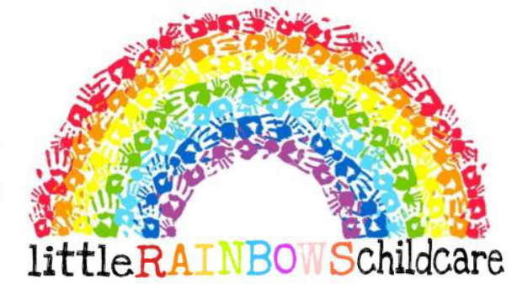

Low Risk Policy
Written by: Jasmine Dean Date: 05/05/2026

1. Policy Statement
Little Rainbows Childcare Ltd is committed to providing a safe, caring and stimulating environment where children can learn, explore and develop through play. We recognise that children need opportunities to take part in everyday activities that involve manageable levels of risk, as this supports their confidence, independence, physical development, problem solving and understanding of how to keep themselves safe.
This policy explains how Little Rainbows supports low-risk play, routines and learning opportunities while maintaining clear expectations for supervision, safe practice and staff judgement. The setting does not aim to remove all risk from children’s experiences; instead, staff support children to take part in safe, age-appropriate activities with sensible boundaries and appropriate adult guidance.

2. Purpose of the Policy
- To support children to safely experience age-appropriate challenges during play and daily routines.
- To help staff understand what is meant by low risk within the nursery environment.
- To promote consistent supervision, safe decision-making and positive adult support.
- To ensure low-risk activities remain suitable for the age, stage, needs and abilities of the children taking part.
- To encourage children to develop confidence, resilience, independence and awareness of safe behaviour.
- To make sure any change in circumstances is responded to promptly and appropriately.

3. Scope
This policy applies to all staff, students, volunteers, agency staff, visitors and contractors while on Little Rainbows premises or taking part in nursery activities. It covers low-risk activities and routines in all areas of the setting, including playrooms, outdoor spaces, toilets, nappy changing areas, sleep areas, kitchen or food preparation areas, entrances and transitions between rooms or activities.

4. What Low Risk Means at Little Rainbows
A low-risk activity is an everyday activity where the likelihood of harm is low and the possible outcome is minor, provided staff follow nursery procedures, supervise appropriately and use suitable resources. Low risk does not mean no risk. Staff must remain alert and responsive because an activity can become unsuitable if circumstances change.
Examples of low-risk activities may include free play, story time, mark making, construction play, role play, music and movement, messy play, sand or water play, outdoor play, simple obstacle activities, gardening, baking preparation, sensory play and daily self-care routines, where these are planned and supervised appropriately.

5. Principles of Safe Low-Risk Practice
- Children are encouraged to explore and develop skills in a safe and supported way.
- Activities are matched to children’s age, stage of development, individual needs and confidence levels.
- Staff use professional judgement and adapt activities when needed.
- Resources are checked before use and removed if damaged, unsuitable or unsafe.
- The environment is kept tidy, calm and organised to reduce avoidable hazards.
- Children are supported to learn safe behaviors through modelling, reminders and positive language.
- Staff maintain appropriate ratios and position themselves so they can observe and respond effectively.
- Any concern, hazard, near miss or accident is reported and recorded in line with nursery procedures.

6. Staff Responsibilities

Registered Provider / Owner
- Ensure the setting has clear arrangements for health, safety and supervision.
- Provide suitable equipment, resources and maintenance arrangements.
- Support the Nursery Manager to review practice following incidents, concerns or changes in the setting.

Nursery Manager
- Ensure staff understand this policy and apply it consistently.
- Make sure daily checks are completed and any hazards are addressed promptly.
- Ensure staffing, deployment and supervision meet children’s needs.
- Review accidents, near misses and recurring concerns to identify whether practice needs to change.

Room Leaders and Practitioners
- Check rooms, resources and outdoor areas before children use them.
- Supervise children closely and adjust activities when needed.
- Use calm explanations and modelling to help children understand safe choices.
- Remove or report any unsafe equipment, spillages, breakages or environmental concerns immediately.
- Consider individual children’s needs, including SEND, allergies, medical needs, mobility, communication and behaviour support.

Students, Volunteers and Agency Staff
Students, volunteers and agency staff must follow nursery procedures and take directions from permanent staff. They must not lead activities or supervise children alone unless this has been agreed by the Nursery Manager and is in line with safer recruitment, suitability and supervision requirements.

7. Supervision During Low-Risk Activities
Staff must remain actively engaged with children during low-risk activities. Supervision should be adjusted depending on the activity, the children involved, the layout of the room, the resources being used and any changes during the session.
- Staff should position themselves so they can see and hear the children.
- Children who need additional support should receive closer adult guidance.
- Staff should scan the area regularly and respond quickly to changes.
- Staff should avoid unnecessary distractions, including personal mobile phones.
- Transitions, outdoor play, mealtimes and toileting routines should be supervised carefully, even where they are usually low risk.

8. Dynamic Decision-Making
Staff are expected to use dynamic decision-making throughout the day. This means noticing when something has changed and taking immediate action to keep children safe while still supporting play and learning where appropriate.
A low-risk activity may need to be adapted, paused or stopped if there is a change such as reduced staffing, adverse weather, broken equipment, spillages, challenging behaviour, a child becoming unwell, an unfamiliar visitor entering the area, or children using resources in a way that was not intended.

9. Supporting Children to Manage Low Risk
Little Rainbows supports children to develop an age-appropriate understanding of safety. Staff should use positive language and clear explanations, for example “walking feet inside”, “hold the scissors safely”, “one at a time on the step” or “let’s check the floor is clear”.
Staff should not frighten children or prevent every challenge. Instead, they should guide children to notice risks, make safer choices and build confidence through supported practice.

10. Inclusive Practice
Low-risk activities must be inclusive and adapted where needed so that children can participate safely. Staff should consider each child’s individual needs, including communication, mobility, sensory needs, allergies, medical plans, SEND support, behaviour support and emotional wellbeing. Where a child needs additional support, staff should make reasonable adjustments and seek advice from the Nursery Manager, SENCO or parents/carers as appropriate.

11. Hygiene and Infection Control
Low-risk activities must still follow hygiene procedures. Staff should wash hands when required, clean resources appropriately, manage spillages quickly and ensure items used for sensory or messy play are suitable, clean and age appropriate. Any activity involving food, water, bodily fluids, toilets, nappies or illness must follow the relevant nursery procedure.

12. Outdoor Play and Physical Challenge
Outdoor play and physical challenge are important parts of children’s learning and development. Staff should support children to climb, balance, run, explore and use equipment safely, taking account of age, ability, weather, surfaces, footwear and the number of children using the space.
- Outdoor spaces should be checked before use.
- Broken or unsafe equipment must be removed from use.
- Children should be reminded of safe boundaries and expectations.
- Staff should remain alert to changes in weather, surfaces and children’s energy levels.

13. Recording and Reporting
Staff do not need to complete a written risk assessment for every ordinary low-risk activity. However, they must report hazards, accidents, incidents, near misses or concerns in line with nursery procedures. Records should be used to identify patterns and improve practice where needed.
Where an activity, outing, new resource, environmental change or individual child need creates a higher level of concern, staff must speak to the Nursery Manager so that suitable controls or a separate written risk assessment can be considered.

14. Partnership with Parents and Carers
Little Rainbows works in partnership with parents and carers to support children’s safety, confidence and independence. Parents and carers should be informed where relevant about activities, expectations, clothing requirements, individual support needs or any concerns relating to their child’s safety and wellbeing.

15. Review of This Policy
This policy will be reviewed annually, or sooner if there are changes to legislation, EYFS requirements, setting practice, premises, staffing, resources, incidents or identified concerns. The Nursery Manager and Registered Provider are responsible for ensuring that the policy remains suitable and is shared with staff.
Signed: J.Dean Review date: May 2029
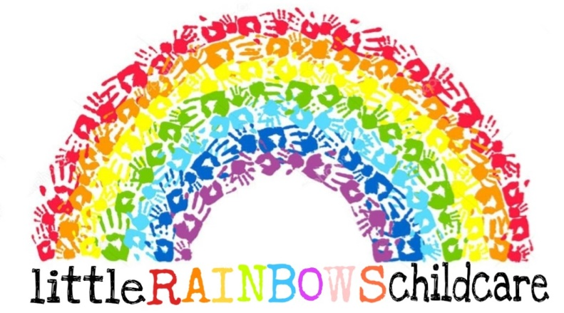
Medication Administration Policy

Written by: Chloe Chubb & Jasmine Dean Date: 05/02/2026

We are committed to ensuring children’s medical needs are met and we will do everything we can to promote the good health of children in my care.

EYFS requirement 3.44 – The provider must promote the good health of children. They must have a procedure, discussed with parents and/or carers, for responding to children who are ill or infectious, take necessary steps to prevent the spread of infection, and take appropriate action if children are ill.

Medication administration procedures to follow…

EYFS requirement 3.45 - Providers must have and implement a policy, and procedures, for administering medicines. It must include systems for obtaining information about a child’s needs for medicines, and for keeping this information up-to-date. Training must be provided for staff where the administration of medicine requires medical or technical knowledge.

During induction, We ask parents about their child’s health and record their replies. If parents inform me about any health concerns I will ask them more questions about their child’s condition and attend training if required.

Caring for children with SEND - We are prepared to make ‘reasonable adjustments’ to the building, garden and / or our ways of working as required by the Equality Act 2010 to support a child’s medical needs. We are also prepared to work with other professionals or agencies with permission from parents to support a child – please see my Permission Form for more information.

Staying updated - We keep information regularly updated to ensure children’s ongoing medication needs are met. If children need medication including liquid medicine, cream, tablets, inhalers, suppositories, specialist feeding equipment etc either short or long term, We aim to support parents and meet each child’s needs and work closely with other agencies as required.

EYFS requirement 3.45 - Medicines must not usually be administered unless they have been prescribed for a child by a doctor, dentist, nurse or pharmacist (medicines containing aspirin should only be given if prescribed by a doctor).

We will administer non-prescription medication. If medication is to be given on a ‘when required’ basis for eg sun protection, nappy rash etc, parents must sign to give me permission in advance and we will inform parents that we have administered the medication or treatment for their child on collection.

Allergic reactions - if a child has an allergic reaction or suspected reaction to any medication or treatment we will stop administering it immediately and request medical advice. We will make every effort to inform parents as soon as practical.

My Medication Administration Record form requires parents to sign twice - once to confirm they want us to give medication / treatment and again to confirm we have given medication / treatment. When children require ongoing medication, permission forms are checked with parents every morning.

Non-prescription medication - EYFS requirement 3.46 - Medicine (both prescription and non-prescription) must only be administered to a child where written permission for that particular medicine has been obtained from the child’s parent and/or carer. Providers must keep a written record each time a medicine is administered to a child, and inform the child’s parents and/or carers on the same day, or as soon as reasonably practicable.

Our medication administration forms are robust. To prevent overdose parents must include information about when medication was last given. If more than one medication is to be given, We need a separate record for each. Please see our ‘medication drop off’ information sheet for parents for more details. We ask parents make themselves available to sign acknowledging their child has been given medication on the same day as the medication has been administered.

Calpol / Child’s Temperatures

In the event your child needs Calpol because they have developed a temperature that is 38 degrees or above we are able to administer Calpol as long as they haven’t been given any prior to attending the setting on that day. This is because if your child needs Calpol again this would indicate that they are unwell due to needing it twice in the same day. We understand that sometimes children develop temperatures due to teething however if your child is teething Calpol will bring this down. If it doesn’t then this indicates that they’re not well, and are at risk of spreading infection amongst the other children. We have to ensure we protect all children’s health and welfare, so if a child is unwell due to these reasons then they will be sent home to control and prevent the spread of infection.

Medication administration procedures
The following procedures must be followed when medication is administered to a child -
- Ensure medication is in a labelled container with dosage information / guidance;
- Ask parents to sign a permission form which includes information about when medication was last given;
- In case of onset of illness, ring parents to advise them that medication needs to be administered;
- Wash hands and prepare medication following information on the enclosed information sheet;
- Respect the child’s privacy by ensuring the child is in a private place when taking medication;
- Complete, sign and date Medication Administration Record form on the same day (if possible).

Note – We will not normally give the first days’ doses of a new medication including antibiotics in case of an allergic reaction. If the child fights or spits or refuses to take medication, we will contact the parents to come and administer. If your child has been administered antibiotics and you bring them into the setting, then they must have been taking them for at least 24 hours before they can attend the setting. This is so we can administer your child’s medication safely, knowing they haven’t had any allergic reactions. This is due to the fact that a child can develop allergies which show up in the first 24 hours on antibiotics.

Record retention – medication records are stored in the child’s personal file and retained for ‘a reasonable period of time’ to comply with the EYFS.

Emergency medication administration procedures
If a child falls ill or there is a medical emergency and a child needs medication we will -
- Make every effort to contact parents and ask for written permission to administer medication;
- Contact NHS Direct (phone: 111) or the child’s doctor (see Emergency Contact Information form) if I am unable to contact parents in an emergency situation and follow their advice;
- Make every effort to contact parents or emergency contacts to collect the child unless the child needs urgent hospitalisation, in which case I will follow my Emergency Procedures;
- Complete paperwork for parents to sign as soon as possible.

Self-medication - we are aware of the need for some older children to carry medication on their person if it is needed at school - this is discussed with the child and parents during induction and regularly reviewed to ensure all children are safe. Parents are informed that we need to be aware of any medication on the premises and we must be confident it is stored safe. Medication use will be supervised when children are on the premises.

Medication storage - medication is clearly labelled and stored out of sight and reach of children. Expiry dates are checked regularly and, if necessary, medication is returned to parents for replacement and safe disposal. Medication is stored in its original container and below 25° c, out of sight and reach of children but immediately accessible in case of a medical emergency. If the prescriber’s instructions are not available with the medication they will be requested before the medication is given to the child.

Specialist training to administer medication - we are happy to attend additional training in addition to the training we have received during my Paediatric First Aid course if required to help me appropriately care for a child.

Caring for children with long-term medical needs - if a child has long-term medical needs we will work with parents to complete a Care Plan for the child which will detail their needs and give me permission to administer medication or treatment long-term or in an emergency situation. All medication administration will be recorded for parents to sign. Information about children’s ongoing medical needs will be updated regularly.

EYFS requirement 3.46 - Medicine (both prescription and non-prescription) must only be administered to a child where written permission for that particular medicine has been obtained from the child’s parent and/or carer.

We will not allow children to share prescription medication. If parents ask me to share children’s prescription medication with another child we will hand it back to them and ask them to take their child to the doctor for a diagnosis and individual treatment.
If you have any questions about my Policy / Procedures or would like to make any comments, please ask.

Signed: C.Chubb, J.Dean Review date: 05/02/2029
Missing/lost child policy

In the extreme event a child goes missing whilst in my care either from the setting or whilst on an outing.

We will ensure that the remaining children are sufficiently supervised and secure.
- A prompt and thorough search will be undertaken of the immediate vicinity.
- We will alert other people of the missing child and make enquiries as to when the child was last seen, and where.
- If the child cannot be found within fifteen minutes, then the Police and the child’s parents will be informed.
- we will make concise and accurate notes of the incident, including a description of the child, to hand to police on arrival.
- Parents of other children in my care may be asked to collect their children from us.

When the situation has been resolved we will review the reasons for it happening and ensure measures are taken to ensure that it does not happen again.
A report will be written, detailing the incident and revised procedures, as soon as possible after the event and a copy sent to Ofsted.

Prevention Measures
Children are always within sight or sound of us, children are never left unattended in a vehicle or outside shops, for example. we do not leave children unsupervised outside nursery gates or in the playground, we always ensure they enter the nursery building. we do not allow children to “play in the street” while in our care as we cannot see/hear them from the building and therefore could not possibly ensure their safety.

At the building
The front door is always locked. The door automatically locks when entering the building, and access outside is through a buzzer system. Children are not permitted to leave the building without a staff member, their parent or authorised person to collect.

On Outings
Children are given safety advice as appropriate for their age, and a meeting point is agreed should they get separated from the group.

Signed: C.Chubb J. Dean Review Date:05/02/2029
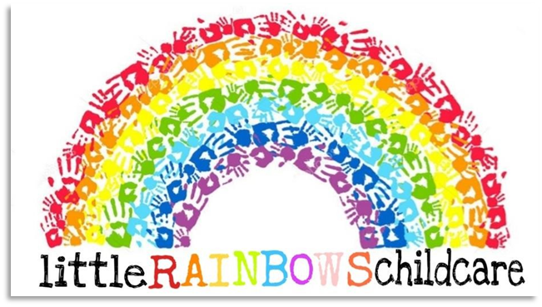
Mobile Phone and Personal Camera Policy
Written by: Jasmine Dean and Emily Garbett Date: 09/03/2026

The welfare, protection, and safety of every child in our care is of paramount importance, we take our responsibility to safeguard children seriously. We have procedures in place which we expect everyone to respect and to help promote the safety of the children in our care.

Little Rainbows Childcare Ltd has a no use of mobile phones policy whilst caring for children. It is our intention to provide an environment in which children, parents and staff are safe from images being recorded and inappropriately used, in turn eliminating the concern of staff being distracted from their work with children and the inappropriate use of mobile phone cameras around children. The only mobile phone that should be used is the work mobile for capturing images for parent partnership and learning journeys for development purposes.

MOBILE PHONES

We believe our staff should be completely attentive during their working hours to ensure all children in the setting receive good quality care and education. Mobile phones must not be used during working hours. Staff are permitted to keep their phones switched on in case of urgent calls, but they will be kept in their bags in the staff room, away from children and must be on silent.

Under no circumstances does the nursery allow a member of staff to contact a parent/carer using their personal device. Users bringing personal devices into nursery must ensure there is no inappropriate or illegal content on the device. All staff must ensure their mobile phones are inside the phone boxes located in the office throughout contact time with children. Staff are permitted to use their mobile phones during their lunch breaks away from the children.
It is the responsibility of all members of staff to be vigilant and to report any concerns to the setting manager.

During group outings a nominated staff member will take the allocated setting mobile phone out with them in case of emergency. This should only be used for emergency calls, under no circumstances must a member of staff take a personal call whilst caring for children.

The manager or deputy manager reserves the right to check the image contents of a member of staff’s mobile phone should there be any cause for concern over inappropriate use of it. Should inappropriate material be found then our Local Authority Designated Office (LADO) will be contacted immediately, as well as the police. Guidance will be followed with regards to the dismissal of the staff member.

Parents & Visitors
Parents or visitors who either arrive using a mobile phone or take a call on a mobile should be immediately told to end their phone call or leave the premises. Visitors are signed into the nursery and asked to leave their personal belongings and mobile phones in the staff room.

CAMERAS & CAPTURING IMAGES

Photographs taken for the purpose of recording a child or group of children participating in activities or celebrating their achievements is an effective form of recording their progression in the Early Years Foundation Stage. However, it is essential that photographs are taken and stored appropriately to safeguard the children in our care.
- Only the designated work mobile phone is to be used to take any photo within the setting or on outings.
- Images taken on this camera must be deemed suitable without putting the child/children in any compromising positions that could cause embarrassment or distress.
- Parental permission is obtained from the parent/carer on joining the setting to the use of photographs in the setting.
- Photos taken on the work mobile can be uploaded to social media, marketing and other children’s learning journeys. This will only occur when we have obtained all the parents’ permission. Any child whose parent has not signed the permission form for photos on social media will not have their photo uploaded.

This policy is in place to protect and safeguard both children and staff.

Only managers on site are allowed their mobile devices on them in the office.

Signed: Review date:
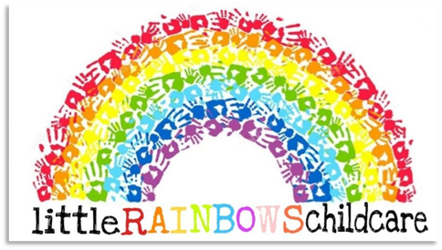

Non/late collection of child policy

It is important that you arrive at the contracted time to collect your child. Even very young children learn our routine and know when their parents are due. They can become distressed if you are late. we know sometimes delays are unavoidable, especially if you are relying on public transport. If you are delayed, for whatever reason please contact us and let us know when you expect to arrive. we will normally be able to accommodate the additional care; however, if we are unable, we will contact other adults from the authorised list and arrange for them to collect your child. We will reassure your child that you are on the way and if necessary organise additional activities.

If a child is not collected within 30 minutes and we have not heard from the parents, we will try contacting them, we will then try the emergency contact numbers. During this time, we will continue to look after the child. After one hour from the original agreed collection time, if we have not heard from the parents or emergency contact, we will contact the Local Authority duty social worker and follow their advice.

If a parent is late collecting their child, they will be charged £5 for every 10 minutes after the agreed collection time. Late fees will be charged at my discretion.

Signed: C.Chubb
J.Dean Review Date 05/02/2029
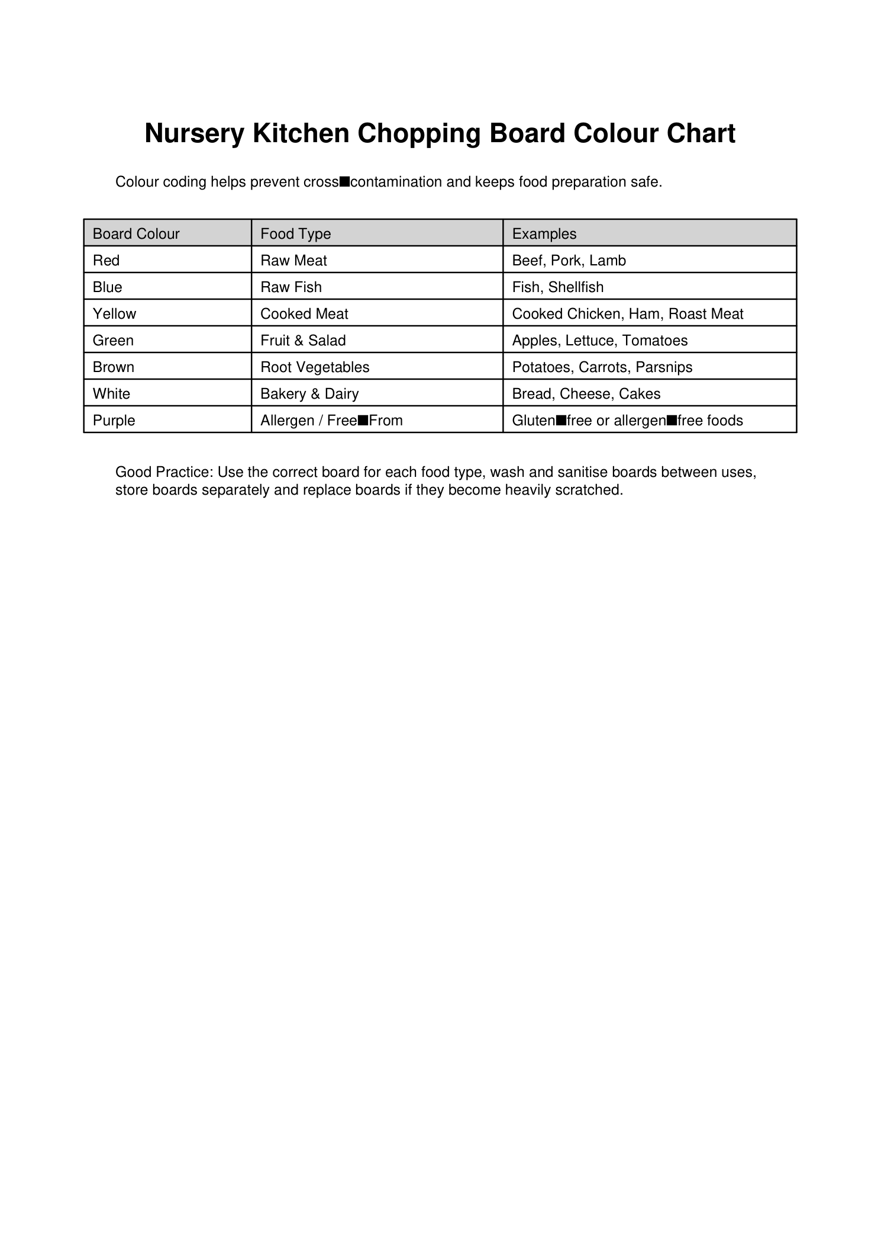
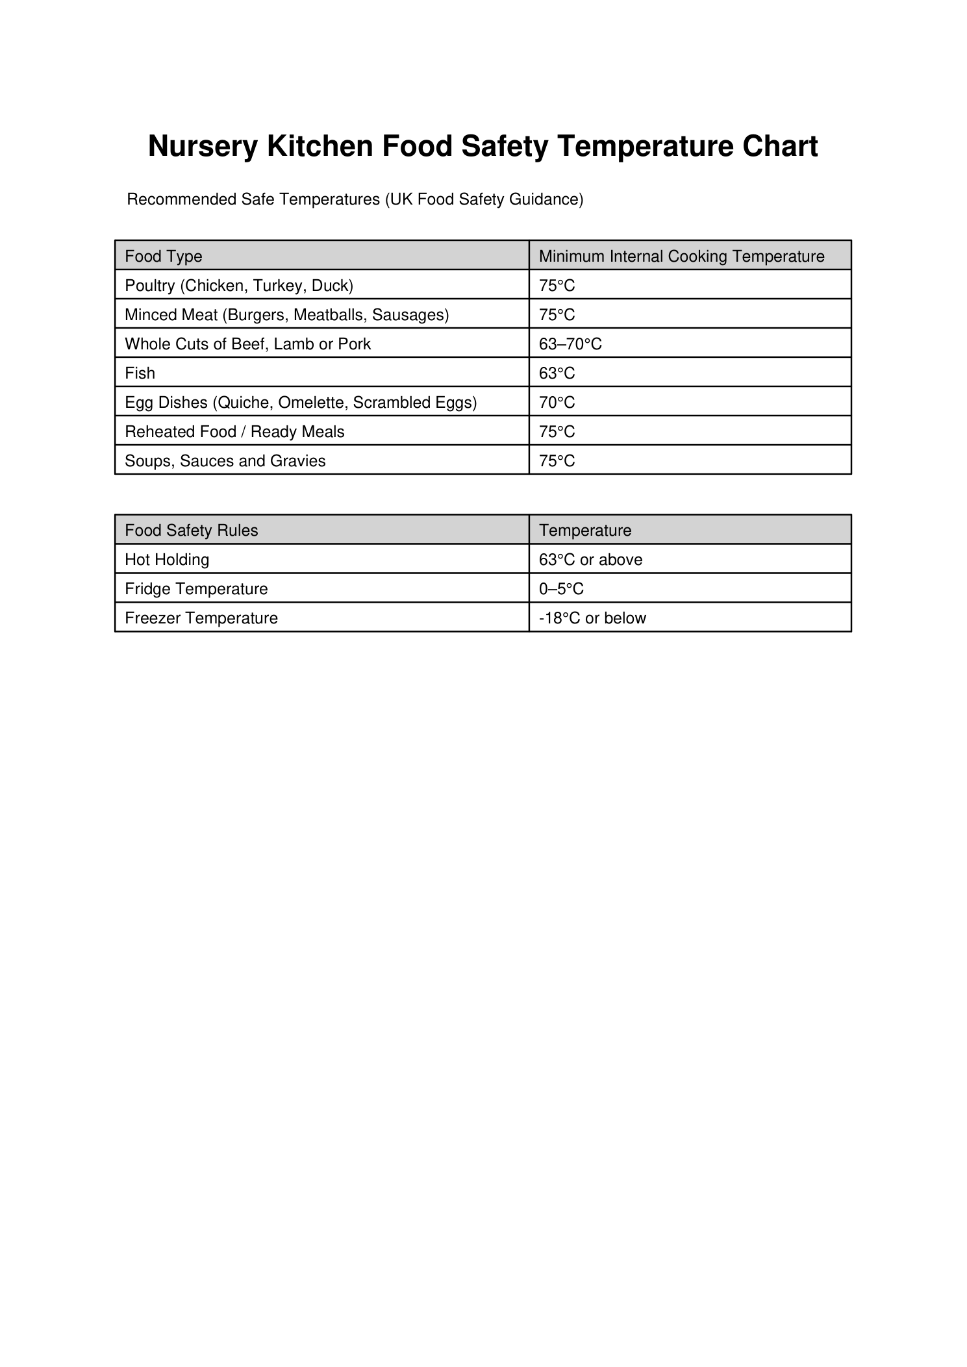
Nutrition Policy

Written by: Jasmine Dean and Chloe Chubb Date: 17/08/2026
Our commitment
At Little Rainbows Childcare Ltd, we want mealtimes to be safe, relaxed and enjoyable. We provide food and drinks that support children’s growth, development, oral health and positive relationship with food. This policy explains, in clear language, what parents and carers can expect from us and what information we need from families to keep every child safe.
This policy reflects the Early Years Foundation Stage (EYFS) statutory framework effective from 1 September 2026 and the Department for Education (DfE) Early Years Foundation Stage nutrition guidance. Where we provide meals, snacks or drinks, they will be healthy, balanced and nutritious. Fresh drinking water will be available and accessible throughout the day.
What parents can expect at a glance
- Fresh water is available throughout the day. For children aged 1 to 5, the other routine drink we offer is plain milk or an appropriate sugar free squash
- We find out about allergies, intolerances, dietary preferences, health needs and feeding or swallowing needs before a child starts, and we keep this information up to date.
- A member of staff with a valid full paediatric first aid certificate is in the room whenever children are eating.
- Children are always within both sight and hearing of a member of staff while eating. Staff members sit with the children during mealtimes.
- Food is cut and prepared in a way that reduces choking risk, taking account of each child’s development and stage of weaning.
- Children are never forced to finish food, and food is not used as a reward for eating.
- Menus and allergen information are shared with parents and carers.
1. Babies: milk feeding and weaning
Birth to around 6 months
- We follow each baby’s individual feeding routine as closely as possible and work in partnership with parents and carers.
- Babies are fed responsively. Staff look for signs that a baby is hungry or full and will never force a baby to finish a feed.
- Breast milk or first infant formula is the main milk feed during the first year, unless a healthcare professional advises otherwise.
- We support families who wish to continue breastfeeding and can safely store and give expressed breast milk in line with current guidance.
- Formula feeds are prepared hygienically, following the manufacturer’s instructions and safe preparation guidance. Bottles, teats and equipment are sterilised as required.
Introducing solid foods / weaning
Weaning usually starts at around 6 months, but children develop at different rates. We do not make decisions based on age alone. We agree with parents and carers how their child is progressing and what textures and foods they are already familiar with.
- We have ongoing conversations with families about the child’s stage of weaning and the textures they can safely manage.
- Food is prepared to suit the individual child’s developmental needs, and textures are progressed at a pace that is right for the child.
- We ask parents which common allergens have already been introduced and agree how allergen introduction will be managed. New foods are introduced carefully so any reaction can be identified.
- From around 6 months, small sips of water can be offered with meals from an open or free-flow cup. Breast milk or first infant formula remains the main drink during the first year.
- Children under 12 months do not normally need snacks. If they are hungry between meals, milk feeds are offered in line with their individual routine.
- Where possible, we use freshly prepared food and a range of tastes and textures rather than relying on commercial pouches. If commercial baby food is used, it will be age-appropriate, checked for ingredients/allergens and suitable for the child.
2. Food and drinks for children aged 1 to 5
Our two-week rotating menu is planned using the DfE Early Years Foundation Stage nutrition guidance. We aim to provide variety across the week and to introduce children to different tastes, textures and culturally diverse foods.
- Fruit and/or vegetables are included with each main meal and with some snacks.
- A starchy carbohydrate such as potato, bread, rice, pasta or another grain is included with each main meal, with a mix of white and wholegrain choices across the week.
- A protein source is provided at lunch and tea. We include a range of meat, eggs, beans and suitable meat alternatives.
- At least one lunch and one tea each week uses beans or a suitable meat alternative as the protein source.
- Children under 2 are offered full-fat dairy foods. After age 2, lower-fat options may be introduced gradually where appropriate.
- Plain, unsweetened dairy foods are preferred. Where a dairy alternative is needed, we use a suitable unsweetened, calcium-fortified option.
- We avoid foods high in saturated fat, salt and/or sugars, such as cakes, sweet or savoury pastries, biscuits, crisps, chocolate and other confectionery, as part of the meals and snacks we provide. Fried starchy foods and processed meat and meat-alternative products are limited in line with DfE guidance.
- We avoid artificial sweeteners and choose lower-sugar and lower-salt options when selecting packaged foods such as bread and breakfast cereals. We’re a nut and fish free setting as some children in our setting are severely allergic.
Drinks
- Fresh drinking water is always available and accessible to children.
- For children aged 1 to 5, routine drinks are fresh water and plain whole or semi-skimmed milk, or appropriate sugar free squash.
- We do not provide fruit juice, smoothies, fizzy drinks or other sugary drinks as routine drinks.
- Skimmed and 1% cow’s milk are not offered to young children as routine drinks.
3. Portions, independence and positive mealtimes
- Portions are suitable for the child’s age, size, appetite and stage of development. We usually start with a small portion and offer more if the child is still hungry.
- Children are encouraged to listen to their own hunger and fullness cues. They are never made to clear their plate or eat more than they want.
- Food, pudding, stickers or other rewards are not used to persuade a child to finish a meal.
- Where safe and appropriate, children are supported to serve themselves, pour drinks and make simple choices, helping them to build independence.
- Mealtimes are calm, social occasions. Children sit safely in an appropriate highchair or suitably sized chair, and distractions are kept to a minimum.
- Staff model positive eating, talk with children about food in a supportive way and avoid labelling foods or children as “good”, “bad”, “fussy” or “naughty”.
4. Safer eating and choking prevention
Keeping children safe while eating is a safeguarding responsibility. There is always a member of staff in the room with a valid full paediatric first aid certificate while children are eating. Staff are always sat with the children while they’re eating.
- Children are always within both sight and hearing of a member of staff while eating. Where possible, staff sit facing children so they can quickly notice choking or an unexpected allergic reaction.
- At every meal and snack time, it is every staff member’s responsibility for checking that the correct food and drink is given to each child, including all allergy, intolerance, cultural and dietary requirements.
- Food is prepared and cut in a way that reduces choking risk and is appropriate for the child’s size, development and stage of weaning. Round foods such as grapes and cherry tomatoes are cut lengthways and then into smaller safe pieces as appropriate.
- We do not give known high-risk choking foods such as whole nuts, popcorn or raw jelly cubes to babies and young children.
- Children are encouraged to sit still while eating and are not allowed to walk or run with food in their mouths.
- Staff supervise closely and discourage food sharing between children, particularly where allergies are present.
- If a choking incident requires adult intervention, we record what happened, tell the parent/carer and review the incident to identify whether any practice needs to change.
5. Allergies, intolerances and special dietary needs
Before a child starts at Little Rainbows, parents and carers must tell us about any food allergy, intolerance, medical diet, cultural or religious dietary requirement, food preference, swallowing difficulty or other health need that may affect eating and drinking.
- This information is recorded and shared with all staff who prepare, handle, check or serve food.
- Parents and carers must tell us promptly if anything changes, including if a new allergy or intolerance is suspected or diagnosed.
- For a known allergy or intolerance, we work with parents/carers and, where appropriate, health professionals to create and maintain an individual allergy action plan. We use recognised allergy action plan guidance, such as BSACI, where appropriate.
- Staff are made aware of the signs of allergic reaction and anaphylaxis, the difference between an allergy and an intolerance, and the emergency action required for the child.
- Required emergency medicines, including adrenaline auto-injectors where prescribed, must be available in line with the child’s healthcare/allergy plan.
- We take steps to prevent cross-contact, including careful storage, preparation, cleaning, handwashing, ingredient checks and separate or clearly identified equipment where needed.
- We do not unnecessarily remove foods from a child’s diet. Where a food must be excluded, we consider a nutritionally suitable alternative.
- Children with dietary needs are included in shared mealtimes wherever this can be done safely. Separate eating arrangements are only used where an individual risk assessment shows they are necessary.
Emergency allergic reaction: If a child shows signs of anaphylaxis, staff follow the child’s emergency plan immediately, administer prescribed emergency medication as trained and call 999. Parents/carers are contacted as soon as possible.

6. Working with parents and carers
- Menus are shared with families
- We share relevant information about what a child has eaten and drunk during the day, particularly for babies and children with individual feeding needs.
- For babies who are weaning, we regularly discuss food textures, new foods, allergens and progress with parents/carers so home and nursery can work together.
- We welcome feedback on menus and take account of children’s preferences, cultural needs and family views when reviewing our food provision.
- Parents and carers can ask to see this policy and discuss any concern about food, feeding, allergies or mealtimes with their child’s key person or a manager.
7. Food brought in from home and celebrations
Where food needs to be brought from home for an agreed medical, cultural or individual reason, we ask families to work with us so that the food remains safe and consistent with our healthy eating approach.
- Food must be suitable for the child’s age and stage of development and prepared to reduce choking risk.
- Lunch bags/containers should be clearly labelled with the child’s name and contents, and perishable foods should be kept safely chilled as appropriate.
- We check food brought into the setting for potential allergens and may ask families not to bring particular foods where this is necessary to protect a child with an allergy.
- We may refuse to serve food that presents an identified allergy, choking or food hygiene risk and will discuss an alternative with the parent/carer.
- For birthdays and celebrations, we encourage non-food celebrations or healthier options. Any shared food must be agreed with the setting in advance and checked for allergens. Sweets and food are not used as rewards.
8. Food hygiene and safe preparation
- Food is stored, prepared and served using appropriate food hygiene procedures and safe temperature controls.
- Our food preparation area and equipment are suitable for preparing healthy meals and snacks. Appropriate sterilisation arrangements are used for babies’ feeding equipment where required.
- All staff involved in preparing and handling food receive appropriate food hygiene training and are expected to follow the setting’s food safety procedures.
- Hands, surfaces and equipment are cleaned appropriately, and allergen cross-contact is managed as part of food preparation and service.
- If food poisoning affects two or more children cared for on the premises, we notify Ofsted as soon as reasonably practicable and within 14 days, in line with the EYFS requirements.
9. Learning about food and sustainability
- Children take part in age-appropriate cooking, baking, growing and food-related activities to build confidence, vocabulary, independence and a positive relationship with food.
- Food activities are planned safely, with allergies, hygiene, choking risks and individual needs considered before the activity takes place.
- We introduce children to foods from different cultures and communities in a respectful and inclusive way.
- Where practical, we use seasonal produce, reduce unnecessary food waste and help children learn where food comes from.

10. Staff responsibilities and monitoring
- Managers are responsible for making sure this policy is understood, implemented and reviewed.
- Staff are responsible for knowing the dietary, allergy, feeding and health needs of the children they care for and for checking these before food is served.
- Menus are reviewed against the DfE food and drink guidance and refreshed at least twice a year, with seasonal changes where possible.
- Choking, allergy and food safety incidents are reviewed so that any patterns or improvements can be identified and acted on.
- The policy will be reviewed at least annually, and sooner if the EYFS, DfE nutrition guidance, Food Standards Agency advice or our setting practice changes.

Signed: C.Chubb J.Dean Review Date: 17/08/2027, or sooner if guidance changes
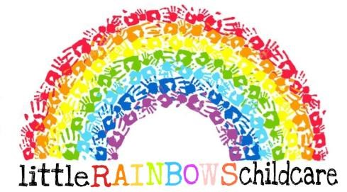

Retainer / Deposit Record

Child’s name - Date of birth -
Retainer - if a place is immediately available, but parents do not wish to take it up, a retainer holds a place open so it is waiting for the child. If the provider cannot offer the child a place when requested by the parent, the retainer must be repaid in full; if parents withdraw their requirement for a place the retainer is kept by the provider.

Retainer fee of £ per week / month

Will be paid to cover the period from: to:

Expected start date - Actual start date -
....................................................................................................................................................
Deposit - a deposit will hold a place open for a child for an agreed period of time. The deposit is normally retained by the provider until the end of the contract and used in payment (or part payment) of the final months’ invoice. It may also be used in case of non-payment of fees (including accrued overtime or late fees) by parents.

A deposit of £ has been paid to secure a future place for - (child’s name)

The place is anticipated to be available from w/c –
When the place has been accepted by parents, the deposit will be returned to parents □ / retained as detailed above and repaid to parents at the end of the contract □

Parent/s signature – Date –
Provider signature – Date –

Fees Policy

I am self-employed and set my own terms and conditions, including fees. It is important that you read through my Fees Policy carefully and understand exactly what is expected of you.

If fees are not paid I am within my rights to immediately terminate care and take legal action against you to recover fees. Legal action might affect your credit rating in the future.

Retainers - deposits – settling-in

Retainers - a retainer keeps a place open for a child if you want to send your child but do not want the space immediately.

We charge half normal fees during the waiting period.

Please note that retainer fees are for me to keep unless the place is not available when you want it, in which case they must be repaid in full. You do not have to pay a retainer fee when I am on holiday or unable to work.

Deposits - you pay an agreed amount of money as a deposit to reserve your child’s place for an agreed date in the future.

We charge one week of normal fees calculated using the child’s usual sessions as a deposit.

If we are unable to offer the place, the deposit will be returned in full - if you cancel the requested place you will lose your deposit.

The deposit will be credited against final fees minus any other charges.

The deposit may need to be adjusted if you change your child’s days / hours in the future.

Registration fee - We do / do not charge a registration fee to cover paperwork and initial information sharing.

Settling in sessions - settling in sessions are an important part of your child’s transition into my care.
We offer 2 x 1 hour settling in sessions free of charge.

We reserve the right to ask you to bring your child for further short settling in sessions if your child does not seem to be settling well. You can ask for extra short settling in sessions if you are worried about how your child is settling in.

If you would like to book further short settling in sessions, please let me know. They will be charged at the normal hourly rate, billed in advance.

Fees payable

Hourly fee - £8.00 per hour
Meal times included in hourly fee - breakfast for children who arrive before 9.90am; morning snack at
9.45am, afternoon snack 2:00pm and high tea at 3.30pm.

Full Time Fee – £1.600 per 4 weeks.
Full day - £80
Half day 8am – 13:00pm £40
13:00pm-18:00pm
If you wish you child to attend between the hours of 7:30am-8:00am this will be additional £5 per session. ( which needs to be booked in prior to the day )

Calculating fees (hourly rate)

Fees are rounded up to the ½ hour. For example -
- If a child is booked to attend from 9 am to 5.30 pm, 9 ½ hours will be charged;
- If a child is booked to attend from 9 am to 5.30 pm but the parent arrives at 5 pm, 9 ½ hours will be charged;
- If a child is booked to attend from 9 am to 5.30 pm but the parent arrives between 5.30 pm and 6 pm, 9 ½ hours will have been charged in advance and ½ hour will be invoiced at the booked or non-booked overtime rate.

The Attendance Register, which must be completed at the beginning and end of each session, will show the exact time each child arrives and leaves the premises and can be consulted at any mutually agreed time in case of a query over hours. If you would prefer to fill in the register at the beginning and end of your child’s sessions, please let me know.

Additional charges
- Provider holiday £ - no charge.
- Provider illness £ - no charge.
- Provider occasional days off £ - no charge.
- Overnight care £ - I do not offer this service.
- Early arrival / late collection - £5 per 10 mins. .
- Child / family holiday £ -. Half fee (minimum 2 weeks notice to be given)
- Child / family illness £ - full fee.
- Parent occasional days off £ - full fee.
- Bank Holidays £ - half fee’s
- Booked overtime £ - normal rate.
- Non-booked overtime - £6 per half hour after 10 minutes. Please remember that overtime is not always available as we are legally required work within Ofsted ratios. we are required to inform Ofsted and my insurance company if non-booked overtime takes me over my ratios.
Note - Non-booked overtime must be paid for in cash on collection of your child. Please consider possible late collections when booking contracted hours, so that non-booked overtime / late fees are not incurred. It is important you let us know as quickly as possible if you are going to be late, so we can reassure your child.
- Provider training days - no charge.
- Outings £ - no charge for routine outings; a contribution towards entrance costs will be requested for special outings which will be discussed in advance.

Food provision
Breakfast, snacks and drinks are included once your child is fully weaned. I do not provide baby milk or weaning meals.
Breakfast - only provided if your child arrives before 9.30am.
- Cost of breakfast for children who attend funded sessions - 75p per breakfast.
Morning snack - 10.30am
- Cost of morning snack for children who attend funded sessions - 50p per snack.
Lunch - 12.30pm
- Parents/Carer must provide a packed lunch
High Tea - 3.30pm
- Cost of high tea for children who attend funded sessions - £1.50 per tea.
Parents are welcome to provide food for their child. Please ask to read my Healthy Eating Policy.
Fresh drinking water is freely available through the day in age appropriate cups.

Other fees information

Funded sessions – I am registered with my Local Authority to offer the funded sessions for 2, 3 and 4 year olds.
Any other hours you wish to book and any meal times will be charged at the published rates.

Extra expenses - extra expenses will normally be agreed in advance. However, this is not always possible. Sundry expenses might include ice creams, sun cream if not supplied by parents, emergency supplies of nappies or baby food etc.
Payment will be requested on the next invoice.

Term time only - I am happy to discuss term time only care.
I charge half fees during the holidays if an early years (pre-school) child attends term time only. This fee is to keep your child’s place open. If you wish to use the space, full fees at the normal hourly / daily will be payable.

Holiday provision only - no holding fee will be charged during term time. Days or sessions will be charged at the normal hourly / daily rate.

Payments

Paying fees - fees are invoiced on the last day of the month for payment during the first week of the following month.
Fees cover all contracted hours for the following month and are payable in advance either weekly or monthly - please let me know which you prefer.
Please remember that the hours charged are the hours held by you for your child’s sole use. Contracted hours are payable regardless of late arrivals, early collections, your or your child’s illness, occasional days off etc (see notes about booking holiday).

Payment options - I accept Bank transfer (BACS), cash, vouchers or a combination of these methods. I do not accept cheques.

Please remember that you are responsible for paying me - not Tax Credits, Care to Learn or voucher companies. If payments are late, it is your responsibility to ensure I am paid.

Payment date - payment must be made monthly in advance 28th of the month.

Unpaid fees - either fees paid in advance for contracted hours or those billed at the end of the month for payment with the invoice will be charged at a late payment rate of £5 per working day, to a maximum of £25.
If fees have not been paid by the end of the first week of the month the contract will be suspended until payment has been made and legal advice will be sought.

Help with fees
Tax credits might pay a percentage of your childcare costs, depending on joint family income. Advice can be found here - https://www.gov.uk/help-with-childcare-costs/approved-childcare. If you need help with claiming Tax Credits or other benefits (letters writing, confirmations of invoices / amounts charged etc), please let me know.

Problems paying fees
Please let me know as quickly as possible if you are having problems paying your child’s fees. I would much rather work with you to resolve the issues than have to cause a child upset and trauma by terminating their contract.

Contract Termination
All fees must be paid in full before the contract is terminated. Contract termination must normally be given in writing giving a minimum of 2 weeks’ (for part time children) 4 weeks (for full time children) notice by either party.

The termination period does not include holiday days / weeks.
The termination period is chargeable at the normal rate. If any fees are outstanding, including any fees in lieu of notice, you will be acting in breach of contract. In such an instance I reserve the right to seek legal advice.
The deposit will be used as payment towards the fees for the last month of your child’s care and any extra fees will be invoiced for payment during the first week of the month.

Fees Review - fees are reviewed annually in August. You will be informed in the August newsletter if fees are changing. This will give you 4 weeks notice so you can adjust tax credits / bank payments / vouchers etc.

Please remember! Booked sessions are reserved for your child’s sole use. This means that I am unable to care for another child on the days and sessions that your child is due to attend. This also means that I charge full fees if the child is dropped off late or collected early... and I do not swap days or hours around... I charge full fees for all booked sessions and overtime if extra sessions are required. I will always invoice parents for booked sessions unless I am ill or on holiday and unable to provide a service.

If you have any questions about my Fees Policy, please do not hesitate to discuss them with me.

Terms & Conditions

Parent details – Date –

It is a requirement of our insurance that a signed Contract, Permissions Form and statutory Policies and Procedures confirmation are in place before your child’s care starts. We commit to complying with the conditions of our insurance and to caring for and providing appropriate developmental experiences for your child, following the requirements of the Early Years Foundation Stage (EYFS) and the Childcare Register (for children over 5 years).

In return, you commit to paying our invoice on time and working closely with us to promote the best possible wellbeing and outcomes for your child. We reserve the right to terminate your child’s Contract immediately and without prejudice in the following circumstances (this list is not exhaustive) –

- If a child or family behaviour threatens the safe running of the setting or the safety of the provider, members of the family etc. Immediate termination might include (but is not limited to) theft or personal physical attacks.
- If you are proven to have failed to maintain confidentiality.
- If you continually bring your child when they are sick.
- If you fail to comply with any of our Policies and Procedures.
- If you fail to work with us to support your child’s care, behaviour, safety, health, learning and / or development.
- If you do not pay our fees (and any late fees that have been accrued) on time as detailed on your invoice.
- If you do not bring your child for 3 □ 4 □ 5 □ continuously booked days without explanation.
- If you fail to reimburse us for any property wilfully damaged by your child.

We reserve the right to request legal advice in the case of Contract termination, which might include contacting Ofsted, the Local Safeguarding Children Board or seeking recourse through the Small Claims Court and our insurance company for non-payment of fees.

Notice of Termination of Contract will be given in writing. The notice period is normally 2 □ 4 □ weeks (not including booked holidays) but we reserve the right to terminate if we feel that continuing the Contract will compromise our wellbeing or the health and safety of the child.

Any variations to these Terms and Conditions will be given to parents in writing. Please sign to confirm you have read, understood and agree with the above Terms and Conditions.

Parent signature – Date –
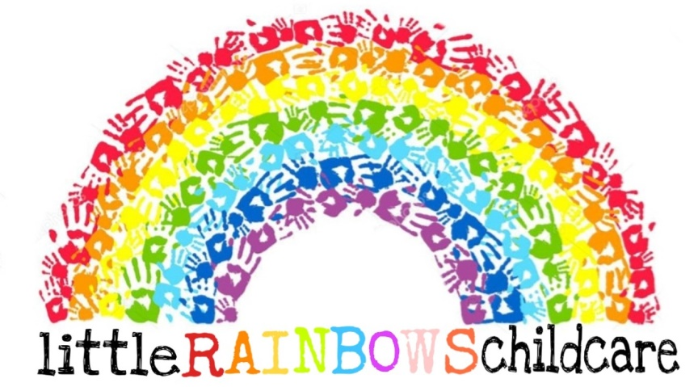

Safeguarding/child protection policy
Emily Garbett is the Designated Safeguarding Lead for Little Rainbows Childcare Ltd
If any of the staff have a cause for concern they will report it to Emily. Emily will then involve any relevant bodies, following the Local Safeguarding Children Board (LSCB) procedures or The Multiple Agency Safeguarding Hub (Family Front Door) Staff members must ensure they’re following safeguarding procedures which involve recognising signs or symptoms of abuse. Responding appropriately- how they deal with the concern so for instance no probing or asking any leading questions. Then they would report the concerns to the DSL Emily. After this staff should record down everything that they have heard, witnessed or seen. This would include details of the time, date and any other relevant information to ensure information is reliable and can be used in court proceedings. The DSL would refer this to any relevant bodies that need involvement for instance LSCB, MASH or depending on the severity of the concern the police.

Child protection is the activity undertaken to protect children who are suffering, or are likely to suffer, significant harm. Safeguarding action may be needed to protect children (and parents) from:

Neglect: Neglect is the ongoing failure to meet a child's basic needs. A child may be left hungry or dirty, without adequate clothing, shelter, supervision, medical or health care. A child may be put in danger or not protected from physical or emotional harm and they may not get the love, care and attention they need from their parents. A child who's neglected will often suffer from other abuse as well. Neglect is dangerous and can cause serious, long-term damage - even death.

Physical abuse: Physical abuse is deliberately hurting a child causing injuries such as bruises, broken bones, burns or cuts. It isn’t accidental - children who are physically abused suffer violence such as being hit, kicked, poisoned, burned, slapped or having objects thrown at them. Shaking or hitting babies can cause non-accidental head injuries. Physical abuse can cause serious, and often long-lasting harm and in severe cases, death.

Sexual abuse: A child is sexually abused when they are forced or persuaded to take part in sexual activities. This doesn't have to be physical contact and it can happen online. Sometimes the child won't understand that what's happening to them is abuse. They may not even understand that it's wrong.

Emotional abuse: Emotional abuse is the ongoing emotional maltreatment of a child. It’s sometimes called psychological abuse and can seriously damage a child’s emotional health and development. Emotional abuse can involve deliberately trying to scare or humiliate a child or isolating or ignoring them. Children who are emotionally abused are often suffering another type of abuse or neglect at the same time – but this isn’t always the case.

Bullying, including online bullying and prejudice-based bullying: Bullying is behaviour that hurts someone else – such as name calling, hitting, pushing, spreading rumours, threatening or undermining someone. It can happen anywhere – at school, at home or online. It’s usually repeated over a long period of time and can hurt a child both physically and emotionally. Bullying that happens online, using social networks, games and mobile phones, is often called cyber bullying. A child can feel like there’s no escape because it can happen wherever they are, at any time of day or night.
Peer on peer abuse: Peer on peer abuse occurs when a young person is exploited, bullied and / or harmed by their peers who are the same or similar age; everyone directly involved in peer on peer abuse is under the age of 18. ‘Peer-on-peer’ abuse can relate to various forms of abuse (not just sexual abuse and exploitation). Research suggests that girls and young women are more at risk of abusive behaviours perpetrated by their peers; however it can also affect boys and young men, those with learning difficulties or disabilities, LGBT Children and young people and those who are from different communities.

County Lines: County lines is a term used for organised drug dealing networks. This is where gangs and organised crime networks groom and exploit children to sell drugs and transport cash. Criminals often target vulnerable children, they groom the children into trafficking their drugs and money, often across counties for the promise of a reward. This crime is often associated with sexual exploitation and human trafficking.
Racist, disability, homophobic or transphobic abuse: This is when someone is treated differently or unfairly because of their race, colour or culture or because of their sexual preferences or gender. People can also experience prejudice, when a decision is made or opinion formed without knowledge, thought or reason, because of their race, colour, culture, sexuality or gender.

Gender-based violence/violence against women and girls: Violence against women is understood as a violation of human rights and a form of discrimination against women and means all acts of gender‐based violence that result in, or are likely to result in, physical, sexual, psychological or economic harm or suffering to women, including threats of such acts, coercion or arbitrary deprivation of liberty, whether occurring in public or in private life.
Radicalisation and/or extremist behavior: Radicalisation is defined as the process by which people come to support terrorism and extremism and, in some cases, to then participate in terrorist groups. Extremism is vocal or active opposition to fundamental British values, including democracy, the rule of law, individual liberty and mutual respect and tolerance of different faiths and beliefs.

Child sexual exploitation and trafficking: Child sexual exploitation is a type of sexual abuse. Children in exploitative situations and relationships receive something such as gifts, money or affection as a result of performing sexual activities or others performing sexual activities on them. Children or young people may be tricked into believing they're in a loving, consensual relationship. They might be invited to parties and given drugs and alcohol. They may also be groomed and exploited online.

Child trafficking and modern slavery are child abuse. Children are recruited, moved or transported and then exploited, forced to work or sold. Children are trafficked for:

- Child sexual exploitation
- benefit fraud
- forced marriage
- domestic servitude such as cleaning, childcare, cooking, forced labour in factories or agriculture
- criminal activity such as pick pocketing, begging, transporting drugs, working on cannabis farms, selling pirated DVDs and bag theft.

Honour based abuse including female genital mutilation and forced marriage: Honour Based Abuse is violence and abuse in the name of honour, covering a variety of behaviours (including crimes), mainly but not exclusively against females, where the person is being punished by their family and/or community for a perceived transgression against the ‘honour’ of the family or community, or is required to undergo certain activities or procedures in ‘honour’ of the family.

Female genital mutilation (FGM) is the partial or total removal of external female genitalia for non-medical reasons. It's also known as female circumcision or cutting. Religious, social or cultural reasons are sometimes given for FGM. However, FGM is child abuse. It's dangerous and a criminal offence. There are no medical reasons to carry out FGM. It doesn't enhance fertility and it doesn't make childbirth safer. It is used to control female sexuality and can cause severe and long-lasting damage to physical and emotional health. FGM may be practised illegally by doctors or traditional health workers in the UK, or girls may be taken abroad for the operation.

A Forced Marriage “is a marriage conducted without the valid consent of both parties, where duress is a factor” (’A Choice by Right’ HM Government 2000).
Substance misuse: Substance abuse is the use of drugs, alcohol, or chemicals. The substance abuse results in physical, psychological, emotional harm to the user or others. Substance abuse is rare before the teenage years. Most frequently abused substances include:

- alcohol
- tobacco
- marijuana
- hashish
- over-the-counter drugs

Domestic violence: Domestic abuse is any type of controlling, bullying, threatening or violent behaviour between people in a relationship. But it isn’t just physical violence – domestic abuse includes emotional, physical, sexual, financial or psychological abuse. Abusive behaviour can occur in any relationship. It can continue even after the relationship has ended. Both men and women can be abused or abusers. Domestic abuse can seriously harm children and young people. Witnessing domestic abuse is child abuse, and teenagers can suffer domestic abuse in their relationships.

Fabricated or induced illness: Sometimes parents or carers will make up or cause the symptoms of illness in their child, perhaps giving them medicine they don’t need and making the child unwell.

We understand that child abuse can be in the form of any of the above bullet points or a mixture of these.
Terrorism and prevent duty.
we are aware that we must have due regard to the need to prevent people being drawn into terrorism. This is referred to in the Prevent Duty. We am also aware of the signs and indicators of extremism or radicalisation. If we had any concerns we would contact the Prevent Officer in our local area and my LSCB as above.

I am aware of the Department for Education telephone helpline (020 7340 7264) to enable staff to raise concerns relating to extremism directly. Concerns can also be raised by email to counter.extremism@education.gsi.gov.uk
Please refer to my Prevent duty and promoting British values policy for further information.

Abuse allegations.
We must notify Ofsted of any allegations of abuse that are alleged to have taken place while the child is in my care, including any allegations against us, or any members of my family, or other adults or children in my home who have had contact with minded children.

We must also ensure that no individual who is unsuitable to work with children has unsupervised access to a child in my care. We have read and understand the safeguarding and welfare requirements of EYFS.

The Children Act and Working Together to Safeguard Children define safeguarding and promoting children and young people’s welfare as:

- Protecting children from maltreatment
- Preventing impairment of children’s health or development
- Ensuring that children are growing up in circumstances consistent with the provision of safe and effective care and taking action to enable all children to have the best outcomes.

If we have reason to believe that any child in our care is being abused in any way we will report the matter, under these circumstances we will not be able to keep information relating to your child confidential but will need to share it with Ofsted as soon as practicable (but within 14 days), Social Services and the Police if requested.
We must notify Ofsted of any allegations of abuse, which are alleged to have taken place while the child is in our care. We will follow the steps contained in the ‘Working Together to Safeguard Children’ guidance and the ‘Dudley Safeguarding and Child Protection Procedures’.

Parents must notify me of any concerns they have about their child and any accidents, incidents or injuries affecting the child, which will be recorded.
I work together with parents to make sure the care of their child is consistent.

If we notice:

- Significant changes in children’s behaviour
- Unexpected bruising or marks or signs of possible abuse or neglect
- Any comments made which give me cause for concern
- Deterioration in general wellbeing which causes concern
- Signs of neglect, abuse or inappropriate behaviour displayed by other members of staff, or any person working with children. For example, inappropriate sexual comments, excessive one-to-one attention beyond the requirements of their usual role and responsibilities, or inappropriate sharing of images
- Any reasons to suspect neglect or abuse outside the setting, for example in the child’s home
We will implement the local safeguarding procedures, without delay to minimise any risk to the child. We will keep a factual record of the concern and will ask the parents for an explanation, providing it would not put the child at risk and contact the local authority.

The EYFS welfare requirements for registered childminders in England require me to let Ofsted know of any concerns that I have reported without delay.

If a child tells me that they or another child is being abused, we will:

- Show that we have heard what they are saying, and that we take their allegations seriously
- Encourage the child to talk, but we will not prompt them or ask them leading questions. We will not interrupt when a child is recalling significant events and will not make a child repeat their account
- Explain what actions we must take, in a way that is appropriate to the age and understanding of the child
- Write down what we have been told using exact words where possible
- Make a note of the date, time, place and people who were present at the discussion
- Report my concerns immediately to the duty social worker who has the experience and responsibility to make an assessment of the situation.

It is not our responsibility to attempt to investigate the situation myself.

Non attendance.

We’re required under the EYFS to record a child’s attendance. Regular non attendance may be referred to the local authority safeguarding children’s board. We will follow up on absences in a timely manner, if a child is absent for a prolonged period of time or if a child is absent without notification from the parent or carer attempts will be made to contact the child’s parent or carer or alternative emergency contacts. Consideration will be given to children’s vulnerability, parents or carers vulnerability and their home life. Any concerns will be referred to the local children’s social care services and or a police welfare check requested.

Private fostering arrangements.

Private fostering is when a child or young person aged under 16 (or under 18 if they are disabled), is cared for and provided with accommodation for 28 days or more by an adult who is not a close relative. A close relative is an aunt, uncle, step-parent, grandparent or sibling, but not a cousin, grand aunt/uncle.

When a child is privately fostered the child’s parents still have full parental responsibility in the eyes of the law.

The law requires that parents and carers and any others directly involved in the arrangement must notify their local authority at least six weeks before the arrangement begins that they intend to privately foster a child.

If an arrangement is made in an emergency the notification must be made within 48 hours.

Although it is a private arrangement there are certain duties and responsibilities under the Children Act, to ensure that children who are privately fostered are protected. It is the job of Children’s Services to check that these regulations are being observed.

We have a legal duty to report private fostering arrangements to the local authority. If we are aware your child is subject to a private fostering arrangement we will contact the Children and Families Helpdesk on 0300 555 0050. Social care will then undertake an assessment of the private fostering arrangement which will include safeguard checks on the carers and contacting the child's parents.

Whistle blowing

Everyone who comes into contact with children and families in their everyday work
has a duty to safeguard and promote the welfare of children.
All childminders, their assistants, students on placement or volunteers have a
responsibility to report abuse and malpractice when it is suspected or if they have
concerns.
Examples of whistle blowing can be if staff leave the room multiple times leaving out
of ratio, inappropriate behaviour towards staff/parents or children. No-one will know
that you have whistle blew this is all confidential. By not complying to the whistle
blowing policy, you are adhering to bad practise and not safeguarding the children
appropriately.

How to report a concern- Firstly a staff member would ask for a individualised meeting with their managers to ensure confidentiality. Then the staff member would choose to whistle blow on a whomever the had a concern over. This process involves looking into the concern and the severity of it. We would ask the staff member to write everything down as specific as possible to ensure the information is accurate and reliable. Once we have evaluated the concern we would take the appropriate action to begin to deal with the allegation that has been made. This may include warnings, disciplinary action or dismissal of a staff member. In events of serious safeguarding concerns management would then report the allegation to the Local Designated Officer (LADO) to ensure all children are protected from harm and are being safeguarded.

Where a staff member feels unable to raise an issue with their employer, all feels that there genuine concerns are not being addressed they should use other cannels open to them:

NSPCC – Whistleblowing advice line is available. Staff can call 08000280285 - 8am till 8pm, Monday till Friday and 9am till 6pm on the weekends.
Email: help@nspcc.org.uk

Mobile phones.

we understand that mobile phones are an everyday part of life for everyone however incorrect use of these can also provide a risk to the child’s safety, so are not permitted to be used on the premises. Please refer to our mobile phone and personal camera policy for more information.

Security Cameras.
All footage attained is protected by GDPR and will never be shared with anyone other than the appropriate authorities if any investigations are taking place.

Lost child and non collection.

As an Ofsted registered provider it is our responsibility to ensure your child’s safety at all times.

If a child is not collected within 30 minutes and we have not heard from the parents, we will try contacting them, we will then try the emergency contact numbers. During this time, we will continue to look after the child. After one hour from the original agreed collection time, if we have not heard from the parents or emergency contact, we will contact the Local Authority duty social worker and follow their advice.

Safe Recruitment

When employing new staff, we will go through extensive procedures to ensure we are employing suitable candidates. We will obtain multiple references from current or previous employers or someone within a senior role with appropriate authority, we will not accept references from family members as this can be biased. We will obtain verification of the individuals most recent relevant period of employment where the applicant is not currently employed. We also ensure all references are electronic and are from a legitimate source. We will always ask why a candidate has left their current role and the reasonings behind this. We will record and gather proof of all qualifications, identity checks and references and DBS reference numbers. As part of the new September 2026 guidelines a staff member’s position won’t be able to commence until their DBS has returned.

First Aid

We make sure all staff’s first aid training is up to date so that they are qualified in safeguarding children, we only allow students/apprentices to be counted in ratio if they hold a valid first aid qualification. Staff will receive continuous first aid training every 3 years to keep up to date with their first aid knowledge.

Toileting / Privacy

As a childcare setting we must ensure children have the right to privacy during imitate times such as nappy changing and using the toilet. For example: making sure children use the toilet one at a time so their rights to privacy are being respected.

Alcohol and drugs

we will ensure that neither we nor anyone else who has contact with the children whilst at our setting, is under the influence of alcohol or any drug which may affect our ability to care for children.

we will not release the children into the care of any parent or carer who we have reason to believe is under the influence of alcohol or drugs. we will contact a person from their emergency contact list and if no one is available to collect the child then we will contact the local authority duty social worker and follow their advice.

Signed: C.Chubb J.Dean Review Date: 05/02/2029
Safer sleeping practices – 2026
Written by: Jasmine Dean and Emily Garbett Date: 14/04/2026

Children are placed down on their back in their own separate sleep space on a firm flat surface such as a cot or sleep matts on the floor. Babies aged 12 months and under must only be placed to sleep in a cot or bassinet. A child under 2 must be returned to their back if they turn onto their stomach to prevent them from suffocation.
Sleep spaces should only contain a firm, flat, waterproof mattress and lightweight bedding which is firmly tucked in around the child below their shoulders to prevent head covering. A fitted sheet should also be used on the mattress so that the bed is appropriately covered for safety and hygiene reasons. Alternatively, a well fitted baby sleep bag may be used. Check the manufacturer recommendations before using a baby sleep bag. Children should be lay down in alternate ways to each other- head to toe. Beds should be positioned at a bum width apart from each other.
Where blankets are used, the child is placed feet-to-foot at the bottom of the cot, with blankets tucked in. It is recommended that cellular blankets should be used as they’re breathable material.
Cots must not contain extra items such as toys, pillows, extra blankets, bumpers, wedges or straps.
Children should not get too hot or cold. The recommended room temperature for babies is 16 – 20˚C. Children’s heads should not be covered.
Children under six months of age must always have an adult with them in the same room for every sleep. All children must be frequently checked when sleeping. At Little Rainbows Childcare we do not leave children unattended when they’re sleeping. There is always a member of staff in the room to make sure sleep checks are carried out every 10 minutes. This is logged down on our paperwork.
Children are always within sight and hearing of staff when sleeping.
Providers must ensure that all staff read NHS advice on sudden infant death syndrome (SIDS).
If you have any questions about our Policy / Procedures or would like to make any comments, please ask.

Signed: J.Dean E.Garbett Review date: 14/04/2029
SEND Policy
Written by: Chloe Chubb and Jasmine Dean Date: 05/02/2026

We are committed to ensuring all children are supported to achieve to their full potential.

EYFS requirement 3.67 - Providers must have arrangements in place to support children with SEN or disabilities.

We welcome children with special educational needs or disabilities (SEND) to the setting and we always looking to improve my knowledge and will work with children’s parents and other settings children attend and professionals who are involved in their lives to ensure all children are cared for appropriately. All children are unique and we plan for each child every session to ensure their individual needs are met. we aim to ensure that all children including those who have special educational needs or disabilities are valued and supported.

We have a copy of the SEND Code of Practice on my computer and we comply with the requirements of the Equality Act (2010) and any further requirements from my Local Authority.

SEND observation
If we think a child might have a special educational need I will -
- Carry out regular observations, assessments, individual planning and tracking for the child;
- Complete a Care Plan if parents inform me about any special educational needs or disabilities;
- Share tracking information with parents and speak to parents about my concerns;
- Discuss what support is available for the child in the provision and locally;
- Ask permission from parents to speak to other agencies or professionals to request advice for the child – see Consent and Information Sharing Form for more information.

Note – where relevant, we have a copy of the Local Authority SEND Local Offer to share with parents.

The EYFS seeks to provide: equality of opportunity and anti-discriminatory practice, ensuring that every child is included and supported

We are aware that inclusion includes girls, boys, men, women, minority ethnic and faith groups, travellers, asylum seekers and refugees, children with special educational needs, gifted and talented children, Local Authority looked after children, sick children, young carers and disabled children and adults.

we aim to be fully inclusive and ensure no child is disadvantaged because of ethnicity, culture or religion, home language, family background, learning difficulties or disabilities, gender or ability. we will meet the individual needs of each child who attends the provision. The environment is tailored to the needs of all children and adapted as required.

we aim to treat all children as individuals and encourage them to respect themselves and others. we aim to include all children in activities and celebrate their family’s special days. we demonstrate equality of opportunity and diversity in my books, posters, music and movement sessions, displays and other resources throughout my provision. we help children learn about the multicultural and diverse society in which they live through planned outings in the local community and further afield.

Working with parents and other settings and professionals
we aim to work with parents, children and other settings where appropriate to ensure children’s individual needs are met. we ask parents to provide information about their child during induction so we can ensure my routines meet their needs. we inform parents about my inclusive ethos so they know that we value and respect the different racial origins, religions, cultures and languages in my multi-ethnic society and challenge stereotypes and inappropriate comments. we ensure documentation acknowledges the uniqueness of every child and we are happy to consider making reasonable adjustments should they be requested by parents.

SEND funding
If a child is eligible for and a parent completes the documentation to apply for Early Years Pupil Premium (EYPP) for their child we will use the funding to promote the best learning and development outcomes for the child, after consultation with parents.
If we believe a child is eligible for any other funding related to their special educational needs and / or disabilities we will speak to parents and discuss how this can be claimed, to help me better support their child in the provision.

If you have any questions about my Policy / Procedures or would like to make any comments, please ask.

Signed: C.Chubb J.Dean Review date: 05/02/2029
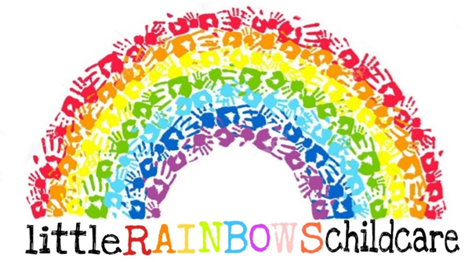

Suncream and Sun Safety Policy
Written by: Jasmine Dean and Chloe Chubb Date: 05/02/2026
Introduction
At Little Rainbows Nursery, we recognise our duty of care in protecting the health and well-being of the children in our setting. Excessive exposure to ultraviolet (UV) rays from the sun can lead to sunburn, skin damage, and significantly increase the risk of developing skin cancer. Research indicates that sun exposure in the first 15 years of life plays a crucial role in determining future risk of skin cancer.
Nurseries have a unique opportunity to help reduce the incidence of skin cancer in future generations through education, behavioural modelling, and environmental management. This policy outlines the steps Little Rainbows will take to promote sun safety.
Aims of the Policy
- To protect children and staff from harmful UV exposure.
- To educate children, parents/guardians, and staff on the importance of sun safety.
- To create a sun-safe environment that reduces the risk of sunburn and long-term skin damage.
Partnership
- We will work in partnership with parents/guardians, nursery staff, and the wider community to promote sun safety and raise awareness of UV protection.
- Staff will act as role models by seeking shade, wearing appropriate sun-safe clothing, hats, and SPF 50+ sunscreen.
- Sun safety information will be communicated to parents/guardians through letters, newsletters, and verbal reminders.
- Parents/guardians will be encouraged to support the nursery's sun safety practices and act as role models for their children.

Education
Sun safety will be embedded into our educational programme to raise awareness and encourage long-term behaviour change.
Children know to get there hat and suncream from the box. Staff will continuously demonstrate how to apply suncream in the right way to ensure children’s skin is fully protected.
Staff will show children an educational and child-friendly video that teaches children about the importance of sun protection. This will be shown throughout the summer season.
Sun safety concepts will be reinforced regularly through discussion and learning activities.
Protection
We will provide an environment that supports sun safety for both children and staff.
a. Shade
Shaded areas are available inside the nursery building and underneath the UV protected gazebo.
Children will be encouraged to use shaded areas during outdoor play, especially during peak sunlight hours (11am–3pm) Staff members will carry out a tuff tray activities underneath the gazebo so children are protected from the UV rays, but are still having outdoor time during the hot weather.
b. Clothing
Parents/guardians will be informed of the importance of appropriate sun-safe clothing.
Children will be encouraged to wear:
Lightweight, Shoulder length tops
Wide-brimmed or neck covering hats
Spare sun hats and quality sunscreen will be kept on site for children who need them or have forgotten them. But parents will be reminded regularly to bring hats and suncream in for their own children.
Parents are requested to bring in a clearly labelled bottle of SPF 50+ sunscreen and hat.
c. Sunscreen
Parents are responsible for applying sunscreen to their child before arrival at nursery. This is known as their base layer of suncream.
Staff will reapply sunscreen (SPF 50+) as needed throughout the day, especially before outdoor activities.
Consent for sunscreen application will be obtained from parents/guardians upon enrolment. This is a written consent form.
d. Hydration
Children will be encouraged to drink water/Juice regularly throughout the day, particularly before and after outdoor play. They will have constant access to fluids from their self-care station. The jugs will constantly be replenished by staff members to ensure there is always fluids for children to access.
Drinking water will be readily available at all times, both indoors and outdoors from our self-care station.
4. Monitoring and Review
This policy will be reviewed annually. Staff will receive periodic training to ensure understanding and effective implementation of this policy.
5. Conclusion
By working together, Little Rainbows Nursery, parents, and the wider community can significantly reduce the risk of sun-related harm to children. Through education, protection, and partnership, we aim to create a safe, healthy, and sun-aware environment for all.

Signed: C.Chubb J.Dean Review Date: 05/02/2029
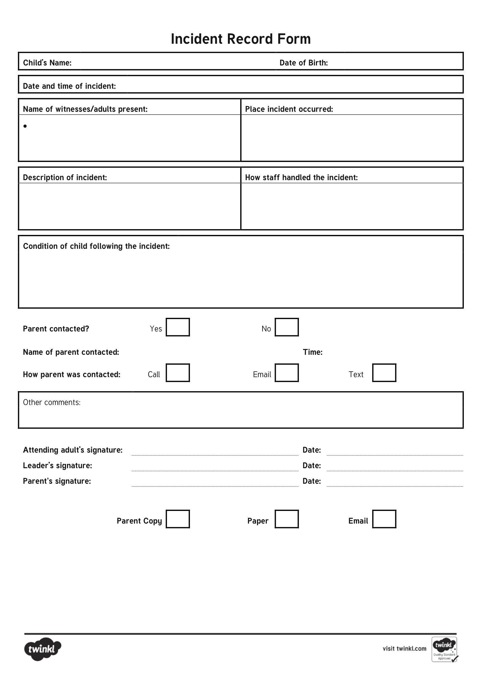
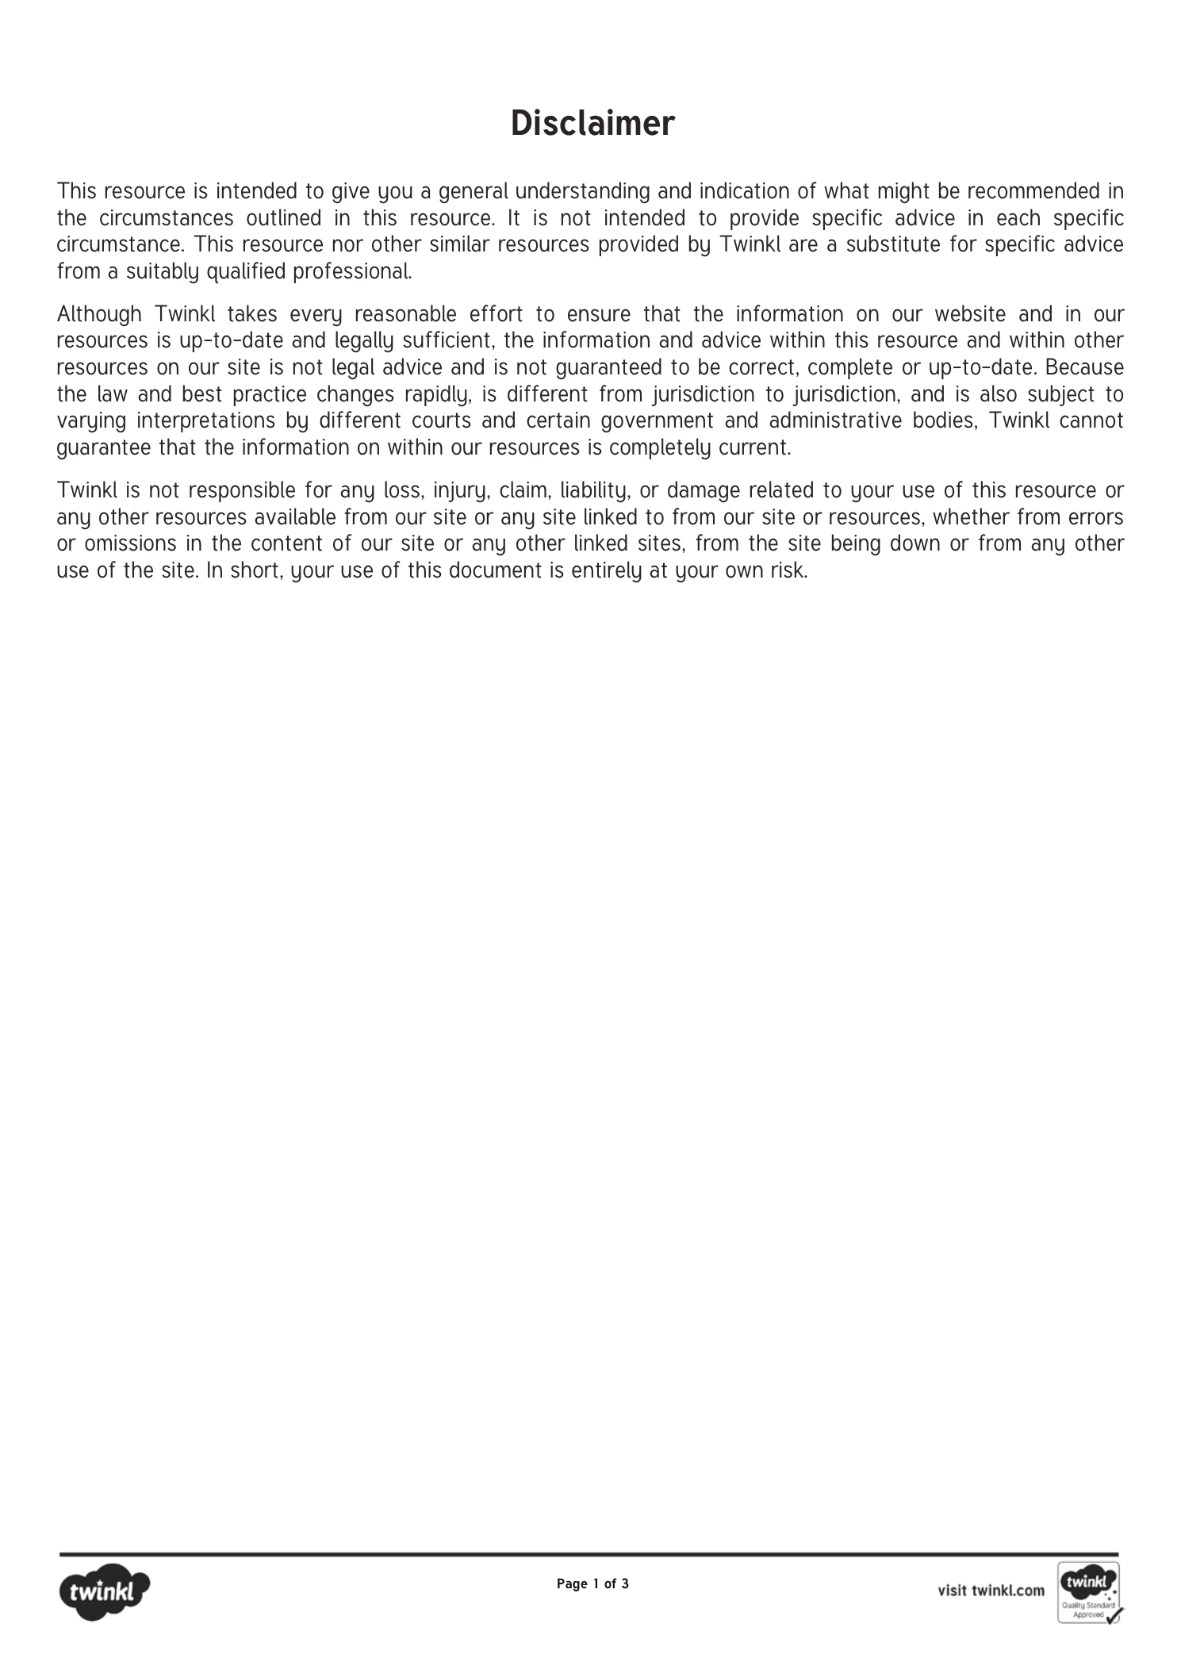
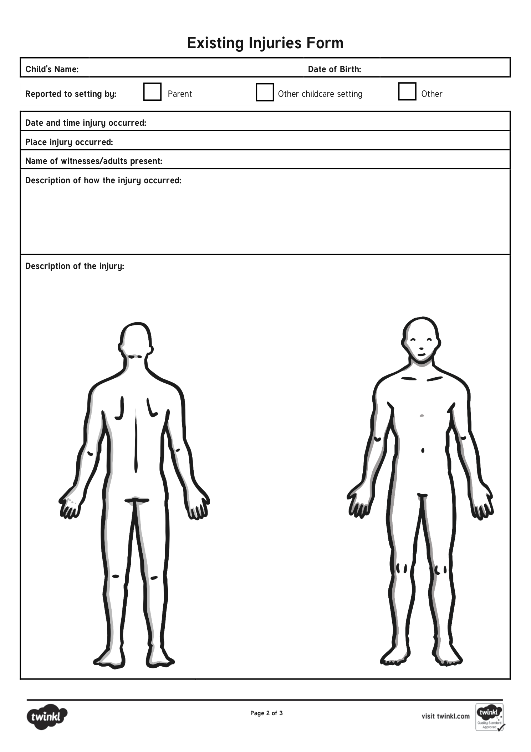
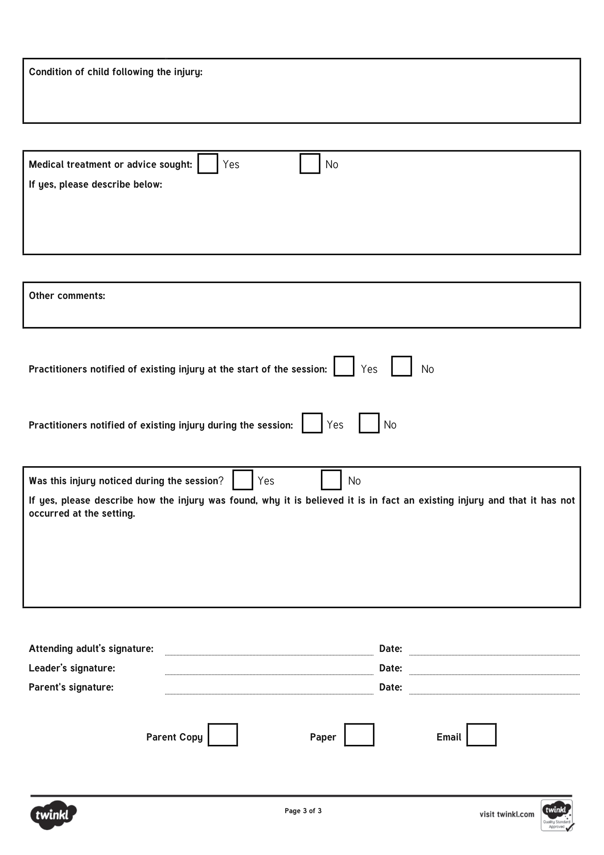

Teething policy

Written by: Little rainbows childcare LTD Date: 05/02/2026

Teething in children may be an uncomfortable and unpleasant experience for both children and parents/carers. Many children begin to teeth around 4 months of age and this can continue up to 24 months although many of the larger teeth will appear before this. Gaps in teething is common and there may be breaks in between teething periods although this differs in all children. Some teeth come through with a child displaying no signs of discomfort or pain.
During teething it is common for children to begin to suck on and chew objects. Teething may also cause a child to begin to bite objects. Although biting is a common response to teething any bite which leaves a mark or a bruise or appears to pierce/break the skin on a child/staff member will be documented and this will be used in accordance with the under 2’s biting policy.
If a child is teething or teething is suspected the parent/carer will be asked to inform a practitioner at the door or via a call or text message.
Practitioners will follow the appropriate steps to help support the child during the teething process this may include
- Offering them teething toys such as rings bracelets etc.
- The use of familiar toys/comforters i.e. a dummy or cuddly toy
- Offering them something cold/soothing for the gums this may include frozen teething toys.
- Cooler foods i.e. a yoghurt (if suitable) if eating/appetite is being affected.
In cases where the following have not been available or suitable for a child the use of teething products is permitted providing it has been brought in from home and permission has been granted by a person with guardianship for the child. Although in the event these are not provided a nursery stock may be used. This may include
- Teething gels /pens
- Teething powders
- Liquid methods (including ambasol).
Although these methods are listed, they are used as a final resort where other methods have not been successful and before they are administered parents/carers will be informed and asked for permission. This will then be documented and stored correctly.

Signed: J.Dean C.Chubb K.Thornley Date 05/02/2029
Toilet Training Policy

Written by: Chloe Chubb and Jasmine Dean Date: 05/02/2026

We aim to support parents through the toilet training process and beyond. We do this initially by offering parents information about the best time to introduce their child to the toilet at home. This includes recognising ‘toilet ready’ signs from your child – toileting is not age dependent but rather linked to children’s physical and psychological readiness. Toilet readiness signs include –

- Is your child's nappy dry after a nap or in the mornings?
- Can your child wait longer between nappy changes, showing they can hold their urine?
- Does your child tell you when their nappy is wet or dirty and they want to be changed?
- Does your child try to pull off their nappy or ask to wear pants?
- Is your child interested in sitting on a potty or toilet?

We will follow home routines to ensure the child is not confused and promote consistency by letting parents know how things are going in the setting and asking parents for regular updates about home toilet use.

We are happy to provide a training child with regular reminders to visit the toilet and to work with parents reward systems if these are found to be helpful at home. We are sensitive to children’s individual needs and have a range of resources to support them including books, role play resources and storytelling props. When children are using the toilet have a special seat to promote their independence, all toilets and sinks are at low level to develop independence; we also teach children how to wash and dry their hands independently.

If a child has a toileting accident we will clean them up, taking a ‘no fuss’ approach to the issue. Parents need to provide at least 3 sets of spare clothes including socks. If age appropriate we suggest the child changes themselves and uses wipes to clean their skin but we do help when requested or if the child is distressed.

Children with SEND will be supported through the toilet training process at whatever age they are ready to start. We will learn a child’s signs (if relevant) and provide them with visual reminders if these are considered helpful by parents and used at home.

If you have any questions about my Policy / Procedures or would like to make any comments, please ask.

Signed: C.Chubb J.Dean Review date: 05/02/2029
Visitor Procedures

Written by: Chloe Chubb and Jasmine Dean Date: 05/02/2026

EYFS requirement 3.62 - Providers must only release children into the care of individuals who have been notified to the provider by the parent, and must ensure that children do not leave the premises unsupervised.

We speak to parents during induction and ask them to record details about their child’s emergency contacts and any people who must not have access to their child.

EYFS requirement 3.62 - Providers must take all reasonable steps to prevent unauthorised persons entering the premises, and have an agreed procedure for checking the identity of visitors.

To keep children safe –
- Doors are locked from the inside, with intercoms with facial recognition
- Visitor ID will be checked before they are allowed on the premises.
- We shadow visitors and do not leave them unsupervised with children
- Visitors are never asked to carry out intimate care routines
- Visitors are asked to put personal belongings in the staff room; to comply with our Mobile Phone and Camera Policy we ask visitors to keep mobile phones and cameras in the office, which is locked at all times
- We share our Emergency Procedures with visitors
- Visitors are not allowed to smoke on the premises.

Unexpected visitors – if we receive an unexpected visitor during working hours, we reserve the right to ring the company to check that the visitor is genuine before allowing them onto the premises.
Record keeping – We record details of visitors for inspection by parents and Ofsted.
Allegations against visitors - if an allegation is made against a visitor, we will follow our Safeguarding and Child Protection Policy and Procedures.
Arrival and Departure Policy has been written and shared with parents.

If you have any questions about our Policy / Procedures or would like to make any comments, please ask.

Signed: C.Chubb and J.Dean Review date: 05/02/2029



Wearable Imagery Devices/Technology
Written by: Jasmine Dean, Chloe Chubb Date: 01/09/2026

1. Purpose and legal basis
Little Rainbows Childcare is committed to protecting children from the safeguarding, privacy, distraction and data-security risks created by personal electronic and wearable devices. This policy explains how wearable technology may and may not be used while children are in our care.
This policy reflects the Early Years Foundation Stage (EYFS) statutory framework for group and school-based providers effective from 1 September 2026. The EYFS requires safeguarding policies and procedures to address how mobile phones, cameras and other electronic devices with imaging and sharing capabilities are used in the setting. The 2026 EYFS also requires providers to have regard to Department for Education guidance on children's screen use.
The Department for Education screen-use guidance applies to digital devices including smart watches. It also states that personal devices must be used in accordance with the setting's safeguarding policy, children should be discouraged from bringing their own devices, and images/videos of children should be kept to a minimum and shared only through secure methods.

2. What is a wearable device?
For the purpose of this policy, a wearable device is any electronic device worn on or carried close to the body that can record, store, display, transmit, receive or share information. This includes, but is not limited to:
- Smart watches and internet-connected watches;
- fitness trackers with messaging, calling, microphone, camera or notification functions;
- smart glasses, including Meta / Ray-Ban Meta glasses and similar camera-, microphone- or AI-enabled eyewear, body-worn cameras and wearable cameras;
- earbuds/headsets with recording, voice-assistant or communication functions where their use could affect supervision;
- GPS trackers or devices with remote listening or recording functions; and
- any future wearable technology with similar capabilities.
A traditional watch or a simple fitness tracker which cannot capture images/audio, make or receive calls/messages, access the internet, or otherwise compromise children's privacy may be permitted, subject to the safety and distraction controls below.

3. Core safeguarding rules
- No personal device may be used to photograph, film, audio-record, live-stream or otherwise capture a child, another family, a member of staff or confidential nursery information.
- Personal wearable devices with imaging, audio-recording, calling, messaging, internet, live-streaming or sharing capabilities must not be worn or used in areas where children are cared for, supervised, changed, toileted, fed or sleeping.
- No personal device may be connected to nursery systems, nursery Wi-Fi, nursery accounts or child-record systems unless specifically authorised by management for a legitimate business purpose.
- Devices must never reduce staff supervision, interrupt interaction with children or distract staff from their safeguarding responsibilities.
- Remote-listening, hidden recording or covert monitoring functions must never be active within the setting.
- Only nursery-authorised devices may be used to take approved photographs or videos of children.

4. Staff, students, volunteers and agency workers
Before entering childcare areas, staff and other workers must remove and securely store any personal wearable that is capable of communication, internet access, photography, video, audio recording, voice-assistant recording, live-streaming or sharing. Smart watches can be worn however; they must have their Bluetooth turned off and not be paired with their mobile phone so they can’t receive data. Personal devices may only be accessed during authorised breaks in a staff-only area away from children, unless there is a genuine emergency and management has agreed their use.
- A basic watch or simple fitness tracker may be worn only where it has no recording/calling/messaging capability, does not display notifications, does not create a hygiene or physical-safety risk, and does not distract from children.
- Where a device has functions that cannot be confidently disabled, it will be treated as a smart device and must be removed.
- Staff must not use personal earbuds/headsets while supervising children, except where required as an agreed disability or medical adjustment.
- Staff must not use personal devices to communicate with parents/carers about nursery matters. Approved nursery communication channels must be used.

5. Medical, disability and reasonable-adjustment exceptions
Little Rainbows recognises that some wearable technology is required for health, disability, accessibility or communication. Examples include continuous glucose monitoring systems, hearing devices, seizure-alert technology or assistive communication devices.
- A necessary medical or assistive device will not be prohibited simply because it is electronic or wearable.
- The manager/DSL will agree an individual arrangement or risk assessment where needed, ensuring the least restrictive approach consistent with safeguarding.
- Any unnecessary camera, recording, messaging or sharing functions should be disabled where reasonably possible.
- Confidentiality and data protection requirements continue to apply.

6. Nursery-owned devices
Nursery-owned tablets, cameras, phones or other digital devices may be used only for an approved nursery purpose and in accordance with safeguarding, data protection and screen-use requirements.
- Devices must be password/PIN protected and accessible only to authorised staff.
- Personal accounts, personal cloud storage and personal social-media accounts must not be used on nursery devices.
- Automatic sharing, nearby sharing, public cloud synchronisation, location sharing and voice-assistant features should be disabled unless specifically needed and approved.
- Images and videos of children must be kept to the minimum necessary. Staff are not expected to collect photographic evidence simply to prove children's learning or development.
- Any approved images must be transferred, stored and shared through nursery-approved secure systems and retained/deleted in line with the setting's data protection and retention arrangements.
- Nursery devices must not be left unattended where children can access them without appropriate adult supervision.

7. Children and wearable devices
In line with Department for Education guidance, children are discouraged from bringing personal digital devices, including smart watches, into the setting.
- If a child arrives wearing or carrying a smart watch or similar device, staff will normally ask the parent/carer to take it home or the device will be switched off and stored securely until collection.
- Children must not use personal devices to take images, record audio/video, make calls, send messages, access the internet or communicate with people outside the setting while in nursery care.
- Devices with remote listening, camera or recording functions must not remain active while the child is in the setting.
- Where a child requires a device for a medical, SEND, communication or other clearly identified need, the manager will agree an individual plan with the parent/carer. Screen-based assistive technology may be used where it supports inclusion and the child's needs.

8. Parents, carers, visitors and contractors
- Parents, carers and visitors must not wear or use smart glasses, including Meta / Ray-Ban Meta glasses or similar camera-, microphone- or AI-enabled eyewear, anywhere on the nursery premises while children are present. This applies throughout drop-off, collection and handover, including entrances, corridors, childcare rooms and outdoor areas. Smart glasses must be removed before entering the setting and kept securely stored until the person has left the nursery premises. This rule applies even where the wearer states that recording, live-streaming or other functions are switched off.
- Parents, carers and visitors must not photograph, film, audio-record, live-stream or make video calls in any area where children can be seen or heard. Any photography expressly authorised by the nursery for a specific event will be subject to separate safeguarding controls and does not override the prohibition on wearing smart glasses during normal drop-off and collection.
- Visitors or contractors who need a device for legitimate work must agree its use with the manager and must not capture children or confidential information.
- Anyone who refuses to remove or securely store a prohibited wearable device, including smart glasses, may be refused entry to childcare areas or asked to leave the premises. Collection or handover will be managed safely by staff without compromising the child’s welfare or safeguarding.

9. Outings and emergencies
On outings, staff must use nursery-approved communication equipment for emergency contact and safeguarding purposes. Personal smart watches or phones must not be used to take images or communicate about children, except in an immediate emergency where there is no reasonable alternative and the action is necessary to protect a child or adult.
Any emergency use of a personal device involving nursery information must be reported to the manager as soon as possible so that safeguarding and data-protection implications can be considered.

10. Children's screen use and wearable technology
Where wearable or screen-based technology is intentionally used with children as part of learning, Little Rainbows will follow the Department for Education screen-use guidance. In particular:
- screen use for children under two will be avoided except in exceptional circumstances, such as a video call with a parent/carer or necessary assistive technology;
- for children aged two to five, screen use will be limited, purposeful and normally kept well within the Department for Education recommendation of up to one hour per day across the child's day, recognising that children may also use screens at home;
- screen activities will be short, adult-supported and linked to a clear learning, communication or inclusion purpose;
- children will not use connected devices unsupervised;
- screens will not be used simply to occupy or calm children, as a routine behaviour-management tool, during mealtimes, or close to sleep unless there is a clear exceptional reason; and
- real-world play, conversation, physical activity, outdoor experiences and responsive adult interaction will take priority.

11. Data protection, privacy and confidentiality
- All use of electronic devices must comply with UK data protection law, confidentiality requirements and Little Rainbows' data protection procedures.
- Children's personal data, photographs, video or audio must never be stored on a personal device.
- Staff must not allow device manufacturers, apps or personal cloud services to upload nursery information automatically.
- If a personal device accidentally captures, receives or stores information about a child, the person must stop using the device and report the incident immediately to the manager/DSL. They must not forward, edit or independently delete the material unless instructed to do so as part of the incident response.

12. Safeguarding concerns and breaches
Any suspected misuse of a wearable or electronic device will be treated seriously. The manager/DSL will consider the nature of the incident, protect the child, preserve relevant information where appropriate, and follow the setting's safeguarding, allegations, whistleblowing, disciplinary and data-breach procedures.
- Concerns about a child's safety will be referred through the setting's safeguarding procedures without delay.
- Where an allegation relates to a member of staff or another adult working with children, the setting will follow local allegations-management procedures, including consultation with the Local Authority Designated Officer (LADO) where applicable.
- Ofsted, the childminder agency (where relevant), the police, social care, the Information Commissioner's Office or other agencies will be notified where the relevant legal or regulatory threshold is met.
- Staff breaches may result in disciplinary action. Serious misuse may amount to gross misconduct and/or a safeguarding allegation.

13. Management responsibilities, training and monitoring
- The manager/DSL will ensure this policy is explained at induction and revisited through safeguarding training and staff meetings.
- Managers will make sure secure storage is available for personal devices and that expectations are applied consistently.
- Staff are expected to challenge unsafe practice and use the setting's whistleblowing procedure if concerns are not addressed.
- The setting may carry out proportionate checks of compliance, for example checking that smart watches are not connected to Bluetooth when staff are in childcare rooms. The setting will not routinely inspect the personal content of staff devices without a lawful and justified reason.
- Parents/carers will be informed that smart glasses, including Meta / Ray-Ban Meta glasses, must not be worn on the nursery premises during drop-off, collection or handover, and of the setting's wider expectations for children's devices and visitor photography/recording.

Signed: J.Dean C.Chubb Review date: 01/09/2028 or sooner if applicable

Working with Others Policy

Written by: Chloe Chubb and Emily Garbett Date: 09/02/2026

we are committed to developing strong relationships with other professionals and agencies involved in children’s lives, to support their learning and to promote safeguarding and child protection.

EYFS requirement 3.67 – Providers must enable a regular two-way flow of information between providers, if a child is attending more than one setting.

we inform parents about the requirement in the EYFS to liaise with other settings and professionals who might be involved in their child’s care and, as appropriate, we will –
- Approach other settings / professionals to find out if and how they are prepared to work with me – for example – letters, telephone conversations, emails etc;
- Provide other settings / professionals with details about the main themes, activities and celebrations children are involved with when they are with us;
- Talk to the child’s key person about what they enjoy doing at the other setting;
- Complete forms or documents for other professionals or agencies on request;
- Take an active interest in what the child does at the other setting and use the information to complement their learning and development experience.

The kind of information we might share includes –
- The name and date of birth of a child with the local children’s centre and on funding forms;
- Behaviour concerns which are occurring across settings;
- Emergency information with my emergency care childminder;
- Health or allergy information to keep the child safe;
- The child’s progress, to ensure activities and routines offered complement each other across settings;
- Information given to the Police, Local Safeguarding Children Board, Health Visitors, Doctors, Social Care etc in an emergency – this list is not exhaustive.

If you have any questions about our Policy / Procedures or would like to make any comments, please ask.

Signed: C.Chubb E.Garbett Review date: 09/02/2029
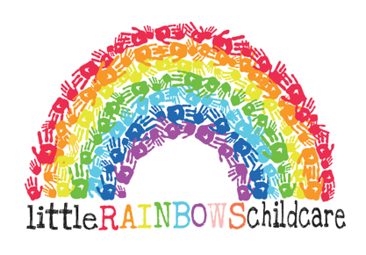
Working with Parents Policy

Written by: Chloe Chubb and Jasmine Dean Date: 05/02/2026

we are committed to working in close partnership with children’s parents and carers.

EYFS requirement 3.68 – Providers must enable a regular two-way flow of information with parents and/or carers. If requested, providers should incorporate parents’ and/or carers’ comments into children’s records.

We aim to work in partnership with parents by, for example –
- Making myself available to talk with parents about their child at all reasonable times;
- Drawing up a written Parent / Provider Contract before children start and respecting parents specific needs where possible, including consistency of care;
- Keeping records of individual family requests and requirements regularly updated;
- Including parent comments in their child’s documents when requested;
- Keeping parents informed about their child’s day and providing written information about daily routines as required by the EYFS – see Daily Routines Planner;
- Sharing information with relevant agencies if, for example, a child is identified as a Child in Need (section 17 of the Children Act 1989);
- Asking parents to inform me of any changes in the child’s life which may affect the child’s behaviour – please see my Confidentiality Policy for more information;
- Offering regular review meetings with parents to discuss their child’s care and education and any issues or concerns they might have;
- Recording significant incidents, accidents etc and sharing information as quickly as practical with parents;
- Notifying parents in advance of Ofsted inspections and asking them to contribute their views – and providing parents with a copy of my Ofsted inspection report after an inspection.
- Sharing new policies with parents, such as my new Arrival and Departure Policy (04.2020), to ensure consistent support for the child/ren.

Please note that, in instances of gross misconduct such as (but not limited to) verbal and physical aggression, theft, damage to my home, racist comments, inappropriate language etc I reserve the right to terminate the contract immediately without notice.

If you have any questions about my Policy / Procedures or would like to make any comments, please ask.

Signed:C.Chubb and J.Dean Review date: 05/02/2029

